|  |  |  |  |  |  |  |  |  |  |  |  |  |
| --- | --- | --- | --- | --- | --- | --- | --- | --- | --- | --- | --- | --- |
| **SOFTWARE DEVELOPMENT GROUP PROJECT**  **2019/2020**  **5COSC009C**  **SOFTWARE FOR DIAGNOSING PARKINSON’S DISEASE**  **KODEMEN**  **Group Members:**   |  |  | | --- | --- | | **Naseer Naseef** | **2018522** | | **Ashfak Ahamed** | **2018602** | | **Ashfaq Khajudeen** | **2018615** | | **Rajeev Kodippily** | **2018639** | | **Vaseekaran Varatharajah** | **2018617** | | **Sarvetha Nadanamainthan** | **2018427** | |

**Abstract**

Parkinson’s Disease is a progressive nervous disorder that affects the movement and functions of an individual. Around 10 million people have been affected by Parkinson’s and has affected Sri Lanka too, as it is stated around 100 people died due to Parkinson’s in the year 2017.

Currently there is no advanced or efficient way to detect/predict Parkinson’s in Sri Lanka, as the only ways that are present are the physical examinations and MRI/CT scans, where the former is ineffective in detecting Parkinson’s at an early stage and the latter is expensive. Therefore, it would be highly beneficial and efficient if there is an alternative way in detecting Parkinson’s.

Our team’s idea is to implement a system that would assist the doctors in detecting Parkinson’s through the speech data. The system would consist of a Machine Learning Model that would be trained with the speech dataset of the patients that our team would acquire. The system would contain an intuitive and clean User Interface and User Experience for the users (i.e. the doctors, medical staff, etc.).

The following report would consist of a Literature Review on the similar system and technologies available, Requirements Gathering, which is a detailed report focused on the ways that the requirements for the systems were gathered and analyzing the stakeholders, Project Management, which depicts the ways that the product would be developed and the Design, which focuses on the system’s design and structure.

**Acknowledgement**

Our team would like to express our gratitude to Guhanathan Poravi (a.k.a. Gugsi Sir) for his guidance and his persistence is pushing us out of our comfort zones to perform better, and also to Banu sir and John sir for assisting us in preparing the documentations and their invaluable comments in improving our project idea.

We would also like to thank Ms. Aberame Thevapalan and Mas. Munshif Mohammed, who assisted us in this project with their knowledge on the problem domain, Ms. Anushiya Thevapalan, who helped us with her valuable ideas in Machine Learning, and other friends who helped us to improve on our project proposal.

We extend our gratitude to the officials, doctors and staff members of the National Hospital of Sri Lanka, who aided us in obtaining the necessary documents and details that would benefit our project, and also to the staff members and non-academic staff members of Informatics Institute of Technology, who gave us invaluable resources and permissions.

Last but not the least, we want to thank our parents for being with us so far, and who will support us immeasurably in the development of our project.

Thank you.

Table of Contents

1 Introduction 1

1.1 Introduction to the problem 1

1.2 Background of Parkinson’s Disease 2

1.3 Proposed solution 3

1.3.1 Obtaining Dataset from Sri Lankans. 3

1.3.2 Method to obtain the required data 4

1.4 Project Aim 4

1.5 Project scope 4

1.5.1 In scope 4

1.5.2 Out of scope 5

1.6 Project objectives 5

1.6.1 Research objectives 5

1.6.2 Operational objectives 6

1.7 Resource requirements 6

2 Literature review 8

2.1 Overview & introduction to the problem domain 8

2.2 Previous projects on detecting Parkinson’s disease 8

2.2.1 Machine Learning Methods to detect Parkinson’s disease. 9

2.2.2 Machine Learning Methods that are already implemented 11

2.3 Previous projects on prediction systems 14

2.4 Previous projects on analyzing audio 22

3 Project management 24

3.1 Chapter Overview 24

3.2 Research methodology 24

3.2.1 Development Methodology to be used in developing the software. 25

3.3 Work Plan 26

3.3.1 Activity Schedule 26

3.3.2 Work Breakdown Structure 27

3.3.3 Gantt Chart 27

3.3.4 Project Roles 27

3.4 Deviations and Risk Mitigation 27

3.5 Chapter Summary 28

4 Requirements specification 28

4.1 Chapter introduction 28

4.2 Requirement gathering techniques 28

4.2.1 Existing Systems 29

4.2.2 Brainstorming 29

4.2.3 Literature Review 30

4.2.4 Questionnaire Results 31

4.3 Use case diagram 36

4.4 Use case description 37

4.4.1 Use Case of Registering to the system 37

4.4.2 Use Case of Adding patients to the system 38

4.4.3 Use Case of Updating patient details in the system 39

4.4.4 Use Case of viewing patients 40

4.4.5 Use Case of Generating Reports 41

4.4.6 Use Case of inputting Speech to the system 42

4.5 Activity Diagram 43

4.5.1 Add patient 43

4.5.2 Input speech to the system 44

4.5.3 Login 45

4.5.4 Registration 46

4.6 Stakeholder Analysis 47

4.7 Requirement Specifications 49

4.7.1 Functional requirements 50

4.7.2 Non-functional requirements 51

4.7.3 Chapter Summary 51

5 Design 52

5.1 Chapter Overview 52

5.2 Design Goals 52

5.3 Rich picture diagram 53

5.4 Machine Learning Design 54

5.5 High level architecture diagram 55

5.6 Class Diagram 56

5.7 System process flow diagram 57

5.8 Sequence Diagram 58

5.8.1 Sequence Diagram for Inputting Speech and ML results 58

5.8.2 Sequence Diagram for Registering Patient 59

5.8.3 Sequence Diagram for Registering User 60

5.8.4 Sequence Diagram for login for user 61

5.8.5 Sequence Diagram for viewing patient detail 62

5.9 Chapter Summary 62

6 Implementation 63

6.1 Chapter Overview 63

6.2 Technology selection 63

6.2.1 Language Selection 63

6.2.2 Libraries/ Frameworks selection 63

6.3 Dataset 63

6.4 Implementation 63

6.4.1 Front-end 63

6.4.2 Machine Learning Engineering 63

6.4.3 Back-end 68

6.5 Chapter Summary 68

7 Testing 69

7.1 Chapter Overview 69

7.2 Goals and objectives of testing 69

7.3 Testing functional requirements 69

7.4 Testing Non-functional requirements 69

7.5 Unit testing 70

7.6 Performance Testing 70

7.7 Chapter Summary 70

8 Evaluation 70

8.1 Chapter Overview 70

8.2 Evaluation methodology and approach 70

8.3 Self-evaluation 70

8.4 Chapter Summary 71

9 Conclusion 71

9.1 Chapter Overview 71

9.2 Achievement of project aim and objectives 71

9.2.1 Aim of the project 71

9.2.2 Completion of objectives of the project 71

9.3 Legal, ethical and professional issues 72

9.3.1 Legal 72

9.3.2 Ethical 73

9.3.3 Professional 74

9.4 Utilizing knowledge from course modules 74

9.5 Learning outcomes 75

9.6 Limitations and problems faced 75

9.7 Future Enhancements 76

9.8 Chapter Summary 76

References 76

Bibliography 79

Appendix 80

Appendix A - Questionnaire 80

Appendix B - Work breakdown structure 82

Appendix C - Gantt chart 83

Appendix D - Project Roles 83

Appendix E - UI wire frame 85

Appendix F – Proposal and permission letter 88

Appendix G – Consent forms 90

Appendix G – Words 94

Appendix H – Pictures of recording patients voice 94

**List of figures**

|  |  |
| --- | --- |
| Figure 4.3.1 - Use Case Diagram | 34 |
| Figure 4.5.1.1 – Add Patient | 41 |
| Figure 4.5.2.1 – Input Speech to the system | 42 |
| Figure 4.5.3.1 - Login | 43 |
| Figure 4.5.4.1 - Registration | 44 |
| Figure 4.6.1 – Stakeholder analysis | 45 |
| Figure 5.3.1 – Rich Picture Diagram | 51 |
| Figure 5.4.1 – Machine Learning design | 52 |
| Figure 5.5.1 – High level architecture diagram | 53 |
| Figure 5.6.1 – Class Diagram | 54 |
| Figure 5.7.1 – System process flow diagrams | 55 |
| Figure 5.8.1.1 – Sequence Diagram for Inputting Speech and ML results | 56 |
| Figure 5.8.2.1 – Sequence Diagram for Registering Patient | 57 |
| Figure 5.8.3.1 – Sequence Diagram for Registering User | 58 |
| Figure 5.8.4.1 – Sequence Diagram for login for user | 59 |
| Figure 5.8.2.1 – Sequence Diagram for Viewing patient details | 60 |
|  |  |

**List of tables**

|  |  |
| --- | --- |
| Table 1.5.1.1 - Research objectives | 5 |
| Table 1.5.2.1 - Operational objectives | 5 |
| Table 1.6.1 - Language resources | 6 |
| Table 1.6.2 - IDEs that is going to be utilized | 6 |
| Table 1.6.3 - Tools that are going to be utilized | 7 |
| Table 2.2.2.1 - Machine Learning Methods to detect Parkinson’s disease | 13 |
| Table 2.3.1 - Feature set | 15 |
| Table 2.3.2 - SVM classification performance results ( Little et al.2009) | 17 |
| Table 2.3.3 - Frequency based features (Sakar et al., 2013) | 19 |
| Table 3.2.1 - Research methodology | 23 |
| Table 3.3.1 - Activity schedule | 25 |
| Table 3.4.1 - Deviation & risk mitigation | 26 |
| Table 4.2.1.1 - Advantages & disadvantages of existing systems | 27 |
| Table 4.2.2.1 - Advantages & disadvantages of brainstorming | 28 |
| Table 4.2.3.1 - Advantages & disadvantages of literature review | 28 |
| Table 4.2.4.1 - Advantages & disadvantages of questionnaire surveying | 29 |
| Table 4.2.5.1 - Questionnaire results | 33 |
| Table 4.4.1.1 Use case for registering system | 35 |
| Table 4.4.2.1 Use case for adding patients to the system | 36 |
| Table 4.4.3.1 Use case for updating patients details in the system | 37 |
| Table 4.4.4.1 Use case for viewing patients | 38 |
| Table 4.4.5.1 Use case for generating reports | 39 |
| Table 4.4.6.1 Use case for inputting speech to the system | 40 |
| Table 4.6.1 - Stakeholder analysis | 46 |
| Table 4.7.1.1 - Requirements specifications | 47 |
| Table 4.7.2.1 - Functional requirements | 48 |
| Table 4.7.3.1 - Non-functional requirement | 48 |
| Table 5.2.1 - Design goals | 50 |
| Table 6.4.2.1 – Accuracy for entire features |  |
| Table 7.3.1 – Testing functional requirements |  |
| Table 8.2.1 – Evaluation criteria |  |
| Table 9.2.2.1 – Completion of objectives of the project |  |
| Table 9.4.1 – utilizing the knowledge from modules in the degree |  |
|  |  |
|  |  |

# Introduction

## Introduction to the problem

Parkinson’s disease (PD) is a slow progressing neuro degenerative disease which affects approximately 1% of people over 60 years of age. There is no known cure for the disease and no laboratory test that can accurately classify patients to be PWP. Thus, there arises an urgent need to find biomarkers to help identify the disease at an early stage. (Sapir *et al,* cited in Hazan *et al.*, 2012)

Studies have suggested that speech abnormalities might be present at early stages of the disease before the classical symptoms of the disease appear. PWP have been identified to have:

· dysphonia (defective use of the voice)

· hypophonia (reduced volume)

· monotone (reduced pitch range)

· dysarthria (difﬁculty with articulation of sounds or syllables)

(Sakar *et al.*, 2013)

Our aim is to use speech analysis techniques to detect speech anomalies in a patient’s voice which are known to appear in the voice of PWP at an early stage of the disease In this context, with a view to enable early detection using a predictive system we identified two issues with the current state of PD diagnosis

1. The invasive nature of current methods that lead to physical inconvenience to the patient.(Sakar *et al.*, 2013)
2. The lateness of the diagnosis resulting in irreversible nerve damage to the patient by the time of diagnosis (Hazan *et al.*, 2012)

Various studies have shown ways to detect voice abnormalities by analyzing different kinds of voice samples from a patient. And, having a rich enough data set with this kind of information would enable us to build a PD detection model that can be used in a PD detection system. This gives us a chance to address both above-mentioned issues regarding PD diagnosis by developing a system that uses acoustic and classification analysis to help identify PWP individuals at an early stage with little or no hindrance to the patient.

## Background of Parkinson’s Disease

Parkinson’s disease is a condition that progresses slowly in a person, and affects the nervous system,especially movement (Mayo Clinic, 2018). As age progresses, the health starts to deteriorate, and life becomes quite hard. And a person having Parkinson’s would have to suffer a lot, and the said person’s family would have to suffer. The exact cause for a person developing Parkinson’s is unclear, but researches have stated that genetics might be a factor, as a person, whose family has a history of being affected by Parkinson’s, has a considerate risk in developing Parkinson’s (NHS Choices, 2019). Some researchers have indicated that environment might affect the chances of developing Parkinson’s, such as the place where the person lives, the food the person intakes, the chemicals the person has come across, etc. but these are not proved and provide no confirmatory results (DeNoon, 2002).

Dopamine is a chemical that is secreted and produced by the neurons, in an area of the brain and is mainly responsible for the movement of the body. When these neurons/nerve cells become weakened or becomes non-functional, the amount of dopamine produced become significantly less, and this results in movement problems; this condition is Parkinson’s disease (National Institute on Aging, 2017). The statistics regarding Parkinson’s Disease are quite staggering, as Parkinson’s is the second most common age-related disorder, behind Alzheimer’s, and it is estimated that around 7-10 million people are diagnosed with Parkinson’s; mostly, people who are older than 50 are affected by Parkinson’s and men are more likely to be affected with Parkinson’s than the women (Parkinson’s News Today, 2017). A person affected with Parkinson’s has to face issues both physically, as well as financially, where it costs quite a fortune to treat Parkinson’s. There is no definitive cure of the syndrome, but treatments and medications are present to make it easier for a patient affected by Parkinson’s. In USA, the total aggregated cost of Parkinson’s to individuals, families are $51.9 billion dollars ,both medical costs and non-medical costs such as lost wages, early retirement, etc. (The Michael J. Fox Foundation for Parkinson’s Research | Parkinson’s Disease, 2019). As it can been seen that treating Parkinson’s is quite costly, and the costs start to soar when the Parkinson’s syndrome is not detected/diagnosed in a person, before it becomes serious. There are no proper and accurate ways to detect Parkinson’s disease currently, such as tests based on biochemical responses, scans, etc. but the detection rather depends on physical tests, such as impaired movements and weak hand to eye coordination. Doctors use scans such as Magnetic Resonance Image (MRI), Computerized Axial Tomography (CAT), Positron Emission Tomography (PET) scans to reject the possibilities of other diseases, rather than directly identifying Parkinson’s (Ng, 2019).Therefore, in order to bridge the shortcomings in properly identifying Parkinson’s in a patient in the early stages, we have come up with a solution, that predicts whether a person is diagnosed with Parkinson’s disease accurately, cost and time efficiently, and we are aiming to achieve this by utilizing Machine Learning.

## Proposed solution

Diagnosing Parkinson’s Disease based on the speech pattern of the person.

▪ This method can be done by analyzing the speech pattern of an individual. The person’s speech would be recorded, and the attributes of the speech would be recorded (i.e. frequency, jitter, shimmer, etc.) and then would be evaluated with the dataset and machine learning, and then the diagnosis of the person would be generated (Uci.edu, 2019).

▪ Dataset for conducting the test:<https://data.world/uci/parkinsons>.

▪ As an added feature, we are trying to obtain dataset of some people in Sri Lanka, who are affected by Parkinson’s, and try to implement a method to detect Parkinson’s based on the national languages (Sinhala or Tamil).

### Obtaining Dataset from Sri Lankans.

As an added feature, which is of utmost importance to our project, we are planning to enable our project to analyze and predict the Parkinson’s disease among the local people of Sri Lanka, as English is not the primary language. Therefore, in order to bridge the language gap among the local, our team has proposed a solution: that is to train the model with the local languages (Sinhala or Tamil) and to come up with accurate predictions.

Since our team lacks the medical background/knowledge to tackle the issue, we are planning to request assistance from a person with the necessary knowledge base, preferably a Medicine Student or a Trainee Doctor.

### Method to obtain the required data

A sample set of around **20-30 patients** affected by Parkinson’s is required in order to train the model. Our team has decided to request permission from the National Hospital of Sri Lanka in order to provide us the necessary speech data required to successfully carry out the project. The speech data would be obtained by utilizing microphones, headphones and a recorder, and to ensure the safety of the patients and to protect the legal and ethical issues of the patients, our team is willing to conduct our recordings within the National Hospital of Sri Lanka, under the supervision of any Doctor or Consultant or any authority figures.

## Project Aim

* **Our aim of the product is to create a system that can accurately predict Parkinson’s disease by analyzing speech patterns.**

Our main aim is to develop a framework which tracks an individual’s speech pattern example to analyze Parkinson's infection. So, the malady can be identified as right on time as could be expected under the circumstances and this item will be valuable for the general population, since many get basic because recently identification of the illness. In this way, with our item we plan to limit hazards so individuals could get brisk truly necessary restorative consideration which will decrease the damages.

## Project scope

### In scope

Following are some of the expected deliverables / product features that would involve the immediate scope of the project.

● A client-server architecture to host a web application

● Users can attempt a simple test:

1. User can attempt to read out a paragraph into the device microphone using their voice

● A section of the system would be dedicated on having background information about Parkinson's disease to further educate the user about the disease.

### Out of scope

Following are some perceived limitations of the system

● The system does not provide medical advice of any sort after the assessment.

● The system only supports the English language only.

● The system is only relevant to Parkinson's disease.

## Project objectives

### Research objectives

|  |  |  |
| --- | --- | --- |
| **Objective ID** | **Objective** | **Description** |
| RO1 | Time-efficient | To provide time efficient diagnosis method to identify Parkinson’s disease. |
| RO2 | Accurate | To provide accurate and cost effective diagnosis method to identify Parkinson’s disease. |

*Table 1.5.1.1 - Research objectives*

### Operational objectives

|  |  |  |
| --- | --- | --- |
| **Objective ID** | **Objective** | **Description** |
| OO1 | User can attempt to rewrite a short pattern | To create a system for the user that they can attempt to rewrite a short pattern on a touch screen using an electronic pen |
| OO2 | User can attempt to rewrite a short paragraph | To create a system for the user that they can attempt to rewrite a short paragraph by using the keyboard input |
| OO3 | User can attempt to read out a paragraph | To create a system for the user that they can attempt to read out a paragraph into the device using their voice. |

*Table 1.5.2.1 - Operational objectives*

## Resource requirements

|  |  |  |
| --- | --- | --- |
| Language | Use | Description |
| Java | Front End | Developing android application and the maintenance. |
| Python | Back End / API | Developing the back end and the RESTful API service.  To develop ML program. |
| HTML | Interface | To Support Angular. |
| Angular | Interface | To create the user and the admin interface. |
| R | Machine Learning | To develop ML program. |

*Table 1.6.1 - Language resources*

|  |  |
| --- | --- |
| IDE | Use |
| IntelliJ | Code Java |
| PyCharm | Code Python |
| Visual Studio | Code HTML, Angular |

*Table 1.6.2 - IDEs that is going to be utilized*

|  |  |
| --- | --- |
| Tools | Use |
| Digital Ocean | Host the system and API |
| Post Men | Test the RESTful API |
| Visual Studio | Code HTML, Angular |
| GitHub | Provide Multiple workspace and resource sharing on development. |
| Spyder | To Test dataset and build an AI model |

*Table 1.6.3 - Tools that are going to be utilized*

# Literature review

## Overview & introduction to the problem domain

Speech abnormalities appear in the voice of People with Parkinsonism (PWP) at an early stage of the disease. These abnormalities can be detected using collecting voice samples of patients and analyzing them using modern voice analysis software. This would in turn enable us to build a machine learning classifier that would help us make a tele monitoring software solution to help doctors make Parkinson’s diagnosis. Our goal is to make this project targeting the Sri Lankan patient demographic by supporting the Sinhala Language and getting the input voice data in Sinhala.

In this chapter we will look at some of the relevant literature to the problem including available datasets and Machine learning techniques which will help us decide what tools would be most appropriate to use in our project

## Previous projects on detecting Parkinson’s disease

Over the years Parkinson’s disease have been identified using various methods. Various researches and projects have been done to detect it. Many methods like machine learning and traditional methods have been used. Algorithms play an important part in Machine Learning. Supervised and Unsupervised algorithms are few of the many categories of machine learning algorithms used frequently.

**Supervised Machine Learning algorithm**

It is the way where an already labelled data can be analyzed to learn a function and give an output for a new unlabeled data. Training the system using datasets until it can give an output on its own. It can be used to solve either classification or regression problems.

**Classification problem**

A classification problem has a distinct answer and it doesn’t have a middle value. We can have a predictor (or predictors) that can be used to give the distinct value as answer. (Medium, 2020)

E.g.: When there’s a system to predict Parkinson’s disease based on age, Age becomes the predictor and the distinct answer could be “Parkinson’s detected” or “Parkinson’s not detected”. It is a standard to represent output (labels) using integers -1,0,1.

**Regression Problem**

A Regression problem has a real number (A number containing a decimal value) as an output. There should be an independent variable as well as a dependent variable. Each row can be called as an observation /data point and each column can be called as a predictor/independent variable. (Medium, 2020)

E.g.: When there’s an analogy of finding the amount of electricity consumed by a certain electric equipment, Electric equipment name can be the independent variable and the electricity consumed (in a decimal point value) can be the dependent variable.

**Unsupervised Machine Learning algorithm**

It is the way where no labels are there to teach the system to give an output. It understands the basic structure of the data to give us a deep understanding about data.

### Machine Learning Methods to detect Parkinson’s disease.

Some of the machine learning methods are clearly mentioned in a research paper by (Bind, Tiwari and Sahani, 2015). Some of the below methods can be used.

**1)** **Artificial Neural Networks (ANN)**

Neural networks are networks of stimulated neurons which can be used to recognize patterns. They learn by searching through a space of network weights. It is used to estimate functions which depends on a large number of inputs and which are generally unknown. ANN are linear statistical learning algorithms inspired from the biological neural networks inside the brain and they are generally a system of interconnected neurons which can compute values of Input/Output, ML and pattern recognition.

**2)** **K-NEAREST NEIGHBOURS CLASSIFIER (K-NN)**

K-NN is an easy to use and implement supervised machine learning algorithm which can be used to classify both regression and classification problems. It is a ‘Lazy type’ algorithm based on learning analogy and used to compare test tuples with training test tuples. When tuples are represented as points in n dimensional space, the known tuple locates the nearest unknown tuple by labelling the unknown tuple with the same class label of the known tuple. The k-NN classifier finds the k-training tuple that are nearest to the unknown tuple. So, the k-training tuples are called the k-nearest neighbor classifier of the unknown tuple.

**3)** **SUPPORT VECTOR MACHINES**

SVM is a learning method based on statistical learning. It is an algorithm based on Linear and non-linear data. It transforms the original data in a higher dimension, from where it can find a hyperplane for separation of the data using essential training tuples called support vectors. SVM creates a hyper plane or a set of hyperplanes in the higher dimensional space which can be used for classification and regression problems.

**4)** **NAÏVE BAYESIAN CLASSIFIER**

Naïve Bayesian classification is called naïve because we can assume it as class condition independent. It means, the effect of an attribute value of given class is independent of the values of the other attributes. This is made to reduce computational costs. It can be very handy in handling large datasets since it’s easy to build and has no complicated iterative parameter estimation.

**5)** **Random Forest**

Random forest Leo Breiman (2001) is a grouping of decision trees-based classifiers. Each tree is constructed by a bootstrap sample from the data, and it uses a selected set of features from a random set. Both bagging and random variable selection can be used for the process of tree building. When the forest is created, test situations are formed down each tree and each tree make their class prediction. Random forest is used to rank the importance of variables in a regression or classification problem.

**6)** **BAGGING**

It is also called as Bootstrap aggregating. It is a machine Learning meta-algorithm to improve the stability and accuracy of ML algorithms used in statistical classification and regression. Over fitting can be avoided and variance also can be reduced by bagging. It also minimizes all the errors caused by noise(caused by target function) ,bias (When algorithms can’t learn the target) and variance (Sampling).

**7)** **BOOSTING**

Boosting is an ML meta-algorithm for decreasing bias primarily and it can also reduce variance in supervised learning. Boosting is also a family of ML algorithms which can convert weak learners to strong learners. Boosting is a generic algorithm which attempts to make better the prediction power by training weak models in succession which compensates the weaknesses of its predecessors.(Medium, 2020)

### Machine Learning Methods that are already implemented

(Rustempasic and Can, 2013) have proposed an approach where they can detect Parkinson’s disease using voice/speech dataset using fuzzy C-means (FCM) clustering and pattern recognition method and they were able to obtain 68.04% accuracy, 75.34% sensitivity and 45.83% specificity.

(Rustempasic and Can, 2013) have proposed a back propagation based approach for the discrimination between healthy and Parkinson diseases affected peoples with the help of artificial neural network(AAN). Boosting was used by filtering technique, and for data reduction principle component analysis was used and they obtained good results with the experiment (Recognition rate of 92%).

Yahia A. et al. (2014) proposed classification algorithm based on Naïve Bayes and K- Nearest Neighbors (KNN).They used Parkinson speech datasets with multiple types of sound recordings to predict Parkinson’s disease. K- Nearest Neighbors performed accuracy 80% and Naïve Bayes classifier performed an accuracy of 93.3% sensitivity 87.5%, and specificity 100%.

Rajnoha, M. *et al.* (2018) proposed an approach to find hypomimia (Expressionless face) from a patient’s static face using parameterization based on face recognition methods in combination with conventional classifiers (random forests, XG- Boost, etc.) .However this approach didn’t outperform the approaches based on video recordings to identify hypomimia.

Drotár, P. *et al.* (2015) in their research proposed to find suitable subset for handwriting features in identifying Parkinson’s disease and to build a predictive model to diagnose PD. Handwritings were collected and In addition to conventional kinematic and spatio-temporal handwriting measures, we also computed novel handwriting measures based on entropy, signal energy, and empirical mode decomposition of the handwriting signals. The accuracy of the classiﬁcation of PD was as high as 88.13% , with the highest values of sensitivity and speciﬁcity equal to 89.47% and 91.89%, respectively.

Dinesh, A. (no date) in his research proposed a model which can diagnose Parkinson’s disease effectively using datasets which consist of voice recordings. The Boosted Decision Tree model was used with an accuracy of 90-95%. It was also discovered through filter-based feature detection that the strongest weighted features were spread1, spread2, and PPE, all three nonlinear measures of fundamental frequency variation in the voice recordings.

A. Sharma et al. (2014) in his research proposed artificial neural network, pattern recognition and support vector machine. It is used to support the experts in the diagnosis of Parkinson disease. Biomedical voice signals of healthy people were used as the dataset for this research and Parkinson disease accuracy was obtained around 85.294%.

Shahbakhi et al. (2014) presented that a Genetic Algorithm (GA) and SVM were used for classification between healthy and people with Parkinson’s. Voice signals that 14 features were based on F0 (fundamental frequency or pitch), jitter, shimmer and noise to harmonics ratio, which are the main factors in voice signal. Results show that classification accuracy 94.50, 93.66 and 94.22 per 4, 7 and 9 optimized features respectively.

Betala E. et al. (2014) proposed a SVM and k-Nearest Neighbor (k-NN) Tele-monitoring of PD patients remotely by taking their voice recording at regular intervals. The age, gender, voice recordings taken at baseline, after three months, and after six months are used as features are assessed. Support Vector Machine was more successful in detecting significant deterioration in UPDRS score of the patients.

|  |  |  |  |
| --- | --- | --- | --- |
| **Researchers name** | **ML methods** | **Dataset** | **Performance** |
| Rustempasic, I. and Can, M. (2013). | fuzzy C- means | Speech signal dataset | 68.04% accuracy, 75.34% sensitivity and 45.83% specificity |
| Rustempasic, I. and Can, M. (2013). | artificial neural network (AAN) | Speech signal dataset | Recognition rate of 92 %. |
| Yahia A. et al. (2014) | Naïve Bayes and K- Nearest Neighbors (KNN) | speech dataset | Accuracy 80% for KNN and Naïve Bayes classifier performed an accuracy of 93.3% sensitivity 87.5%, and specificity 100%. |
| Rajnoha, M. *et al.* (2018) | Face Recognition pattern with random forests and XG- Boost, | Static face Picture dataset | The decision tree algorithm achieved the best accuracy (67.33 %). The |
| Drotár, P. *et al.* (2015) | conventional kinematic and spatio-temporal handwriting measures | Handwriting Dataset | Accuracy of 88.3, sensitivity and speciﬁcity equal to 89.47% and 91.89%, respectively. |
| Dinesh, A. (no date) | Boosted Decision Tree model. | speech dataset | Accuracy of 90-95%. |
| A. Sharma et al. (2014) | artificial neural network, pattern recognition and support vector machine | Speech signal dataset | Accuracy was obtained around 85.294% |
| Shahbakhi et al. (2014) | Support Vector Machines (SVM) | Speech signal | dataset 94.22% accuracy, 70.12% sensitivity and 92.8% specificity |
| Betalu E. (2014) | SVM | Age, gender, voice recording | 76% accuracy 34% sensitivity |

*Table 2.2.2.1 - Machine Learning Methods to detect Parkinson’s disease*

## Previous projects on prediction systems

To start our project, we first needed an existing dataset with multiple speech recordings or we needed to gather data and make our own dataset. We found two such existing datasets.

The first one was based on Little *et al.*(2009) which explored the usefulness of using dysphonic measurements to discriminate healthy people with PWP. Two types of recordings can be obtained from patients in these types of cases.

1) Running speech (normal sentences)

2) Sustained phonations (vowel sounds)

In this paper they only focused on sustained phonation tests because they believed that while running speech can be used to make a full assessment of vocal impairment, sustained vowel recordings will suffice to identify PD discriminative voice disorders in the patient. The collected data contained 195 sustained vowel phonations from 31 male and female subjects out of which 23 were PWP. The table below details the 22 different features extracted from the collected data.

|  |  |
| --- | --- |
| **Feature** | **Description** |
| MDVP: Jitter (%) | Kay Pentax MDVP jitter as a percentage |
| MDVP:Jitter(Absolute) | Kay Pentax MDVP abs jitter in microseconds |
| MDVP:RAP | Kay Pentax MDVP Relative Amplitude Perturbation |
| Jitter:DDP | Average absolute difference of differences between cycles, divided by the average period |
| MDVP:Shimmer | Kay Pentax MDVP local shimmer |
| MDVP:Shimmer(dB) | Kay Pentax MDVP local shimmer in decibels |
| Shimmer:APQ3 | Three point Amplitude Perturbation Quotient |
| Shimmer:APQ5 | Five point Amplitude Perturbation Quotient |
| Shimmer:DDA | Average absolute difference between consecutive differences between the amplitudes of consecutive periods |
| NHR | Noise-to-Harmonics Ratio |
| HNR | Harmonics-to-Noise Ratio [37] |
| RPDE | Recurrence Period Density Entropy |
| DFA | Detrended Fluctuation Analysis |
| D2 | Correlation dimension |

*Table 2.3.1 Feature set (Little et al.2009*

SVM classification is used in this study to perform PD discrimination after constructing a set of feature vectors from the speech signals. The entire machine learning process used can be summed up into three parts

1) Calculating the features

2) Pre-processing and pre-selection of features (both standard and non-standard)

3) Application of a classification technique to all possible feature subsets and selecting the subset that produces the best performance.

The table below shows the performance of each SVM feature set when it came to discrimination PWP with healthy individuals. It proves their main finding that “non – standard measures significantly outperform the traditional measures in separating healthy controls from PWP in terms of overall correct classification performance”(Sakar *et al.*, 2013)

|  |  |  |  |
| --- | --- | --- | --- |
| Feature set (# of measures) | **Correct overall** | True positive | True negative |
| HNR, RPDE, DFA, PPE (4) | 91.4±4.4 | 91.1±4.9 | 92.3±7.0 |
| All(10) | 90.6±4.1 | 90.7±4.3 | 90.4±8.6 |
| RPDE, DFA, PPE (3) | 89.5±3.9 | 89.6±4.3 | 89.1±8.6 |
| DFA, PPE (2) | 88.8±3.8 | 88.2±4.2 | 88.0±8.1 |
| PPE (1) | 85.6±5.4 | 85.9±5.5 | 91.4±4.4 |
| MDVP:Jitter(Abs)(1) | 80.6±9.9 | 80.7±10.1 | 91.4±4.4 |
| RPDE, DFA (2) | 79.2±4.2 | 79.2±4.5 | 79.0±7.5 |
| HNR(1) | 77.4±2.8 | 77.6±3.1 | 76.9±4.1 |
| MDVP:APQ(1) | 91.4±4.4 | 76.8±4.3 | 76.2±6.5 |
| D2(1) | 76.7±1.9 | 76.9±2.2 | 76.1±3.1 |
| DFA(1) | 75.9±2.8 | 76.1±3.1 | 75.4±4.6 |
| RPDE(1) | 75.7±1.4 | 75.9±1.7 | 75.2±3.0 |
| Jitter:DDP(1) | 75.6±2.4 | 75.7±2.3 | 75.2±3.6 |
| NHR(1) | 75.4±0.0 | 75.5±0.0 | 75.0±0.0 |
| Shimmer:DDA(1) | 75.4±0.0 | 75.5±0.0 | 75.0±0.0 |

*Table 2.3.2 SVM classification performance results ( Little et al.2009)*

The second dataset we considered was based Sakar *et al*. (2013). The main difference between this dataset and the previous one considered is that this data set contained running speech recordings along with sustained vowel recordings for the feature set. The researchers in this more recent paper found that sustained vowels carry more PD discriminative characteristics, so they modeled their data collection to have 26 different voice samples that reflected vowel sounds very well.

The voice samples in the training set were taken from 20 PWP (6 females, 14 males) and 20 healthy individuals (10 females, 10 male). The recordings contained

* Numbers form 1-10
* 4 Rhymed sentences (Turkish)
* 9 words (Turkish)
* Sustained vowels “a” , “o” and “u”

The test data set consisted of data from 28 PD patients of 62.67 average ages who have had PD for 0-13 years. Each patient was asked to say the sustained vowel “a” and “o” three times making a total of 168 recordings. This dataset is used to validate the results obtained using the training data. These were recorded under the same conditions as in the training set.

Below is a list of the 26 different voice samples we will be collecting with the corresponding frequency-based feature extracted from each sample. The voice analytics software *Praat* would be used to extract the following features from the recorded voice samples.

|  |  |
| --- | --- |
| Jitter (local)  Jitter (local, absolute)  Jitter (rap)  Jitter (ppq5)  Jitter (ddp) | Frequency Parameters |
| Number of pulses  Number of periods  Mean period  Standard deviation of period | Pulse Parameters |
| Shimmer (local)  Shimmer (local, dB)  Shimmer (apq3)  Shimmer(apq5)  Shimmer (apq11)  Shimmer (dda) | Amplitude Parameters |
| Fraction of locally unvoiced frames  Number of voice breaks  Degree of voice breaks | Voicing Parameters |
| Median pitch  Mean pitch  Standard deviation  Minimum pitch  Maximum pitch | Pitch Parameters |
| Autocorrelation  Noise-to-Harmonic  Harmonic-to-Noise | Harmonicity Parameters |

*Table 2.3.3 Frequency based features (Sakar et al., 2013)*

The classification was done in this research using both K-NN and SVM and the results were compared. They found that rather than using each voice recording of each subject as an independent data sample, “representing samples of a subject with central tendency and dispersion metrics improved the generalization of the predictive model.” (Sakar *et al.*, 2013)

In their results they show that SVM classifier produced higher accuracies than k-NN classifier, the highest being 77.50 %. This was obtained with the s-LOO ( summarized leave one out) method by summarizing data using the mean-standard deviation binary combination of central tendency and dispersion metrics. It is worth noting that the highest accuracy obtained here is lesser than the accuracy obtained from the previous study that we compared that used only vowel sounds in their dataset even though the classification methods are quite similar. (Both uses SVMs)

**The proposed data set and conclusion.**

After comparing the two datasets as above, we thought of adopting the second data set to our project since we were able to make the system for the Sri Lankan patient demographic.

To accommodate Sinhala speaking only patients we need to come up with two separate test and training datasets. We propose a dataset like the one explained above, but we replace the Turkish and English words and sentences with Sinhala ones. The numbers will be read in Sinhala. The sustained vowels will be recorded the same way since the language barrier should not affect the patient’s ability to pronounce the vowels.

To test our model a similar test set to the one mentioned in the original study will be collected under similar conditions to the training set data.

It is important to note that since sustained vowels are found to carry more PD-discriminative information (Sakar *et al.*, 2013), the words and sentences we choose should be picked to reflect as much vowel sounds as possible. Some candidate words and sentences are shown below.

* 4 Rhymed sentences

1. අය්යා ඊයේ උදේම ඕපනායක ගියේය.
2. ඕශදී ඊයේ උනු උනු ආප්ප කෑවාය
3. අමර ඕවිට ලග තිබූ ඊතන මිටිය උස්සාගෙන අවේය
4. ඌරා ඊයේ ඊරීට ආලය පෑවාය

* 9 Sinhala words
  + අග්ගලා
  + ඊතලය
  + ආලය
  + උකුස්සා
  + මුරුන්ගා අලය
  + නාගරාජයා
  + නාඉමන
  + අනුරාදපුරය
  + ඉත්තෑවා

To make reasonable enough predictions we propose to obtain data from a minimum of 16 PD patients and 16 healthy individuals for the training set and 4 PD patients and 4 healthy individuals for the testing data set. Of course, more test subjects will increase the overall accuracy of our predictions and we can always add new data and refine our model anytime.

As far as the ML approach we are to take, after comparing numerous literature with different ML algorithms and varying accuracy we decided to use the kernel-based extreme learning machine subtractive clustering features weighting approach to do our classification (Ma *et al.*, 2014) since it had the highest accuracy rate out of all the compared techniques. We will ultimately come up with a hybrid system containing our own data set with “Sinhala” language recordings and use machine learning techniques used in Ma *et al.*(2014) to do our classification.

## Previous projects on analyzing audio

The human speech production system comprises of a framework of articulators which, when utilized agreeably, permits a speaker to create an endless run of sounds. The framework is physiologically complex. The lungs, in simplified terms it can be thought of as an air pump giving the fundamental wind stream to stimulate the voice source and vocal tract. The term voice quality envelops a wide extend of voice characteristics extending from whispery to breathy, from remiss to tense, from creaky to falsetto, from stressed to non-stressed, and from low-pitched to high-pitched. In order to get how different voice qualities are created, it is vital to dive into the properties of the voice source (Shue, 2010).

Voice analysis was first used in World War II for military intelligence purposes. Every individual’s voice has a unique quality because the anatomy of the vocal cords, vocal cavity, and oral and nasal cavities is specific to the individual. Added to that, to produce words, each person controls the lips, tongue, soft palate and jaw muscles differently (Voice Analysis | Encyclopedia.com, 2019).

Researchers from a variety of medical centers, universities and healthcare companies have collected voice recordings from hundreds of patients over the past few months and fed them to machine learning software that compares voices to those of healthy people, with the aim of establishing patterns that are sufficiently clear to identify vocal disease indicators (Griffin, 2017). The Mayo Clinic has collaborated with Beyond Verbal, an Israeli company to study the voices of coronary artery disease patients using machine learning (AI-Siddiq, 2018). Shinichi Tokuno developed the ‘MIMOSYS (Mind Monitoring System)’ system which automatically monitors the mental health of the owner of the smartphone from their voice during conversations on the smartphone which captures the emotions whether the person is stressed or depressed from changes in the basic frequency of the voice (Steph Hazlegreaves, 2019).

The German company uses voice analysis to identify ADHD (Attention Deficit Hyperactivity Disorder) in children, gaining more than 90% precision in the detection of previously diagnosed children based on their own speech (Griffin, 2017). Boston-based company worked with the Department of Veterans Affairs to use speech recognition software to track the moods of service members and minimize the suicide rate in military service members (Griffin, 2017). In June 2016, the US Army partnered with MIT’s Lincoln Lab to develop an algorithm that diagnoses mild traumatic brain injury using voice (Griffin, 2017).

# Project management

## Chapter Overview

In this chapter, the available methodologies that are available to develop our project would be discussed and a suitable methodology would be chosen with justifiable reasons. The team’s work plan in tackling the project successfully and the roles of each member would be discussed in this chapter.

## Research methodology

|  |  |  |
| --- | --- | --- |
| **#** | **Methodology Name** | **Description** |
| 1 | Agile Model | This model is useful in developing projects that should be developed within a certain time period. Here, the project is developed in incremental cycles and the results will be released after each cycle. This enables the developers to make updates on the previous releases. Regular updates and late changes can be facilitated in this model. |
| 2 | Waterfall Model | One of the earliest models that was implemented and used in the early stage of developments. This is a linear life cycle model, and it is required to complete one phase completely before moving on to the next phase. Very easy to use and understand. But this has limitations: unable to go back to previous phases, therefore cannot change the design of the project during development, and software testing can be done after the development is completed. |
| 3 | Rapid Application Development model | In this model, both the functions and the components are built parallelly and this gives a steady and clear output. Time boxing is used in development and then assembled together to form a working prototype. This model requires meticulous and clear planning. This model facilitates in increasing the components reusability and this model can be recommended for highly experienced developers. |
| 4 | Spiral Model | Spiral model consists of 4 main phases: planning, risk analysis, engineering and evaluation. This model passes through these 4 phases rapidly and it is somewhat similar to Waterfall and Agile models. |

*Table 3.2.1 - Research methodology*

### Development Methodology to be used in developing the software.

Our team has decided to create a system in a methodology that would be adapted to frequent changes and to create a working prototype.

Waterfall methodology is not suitable for our style of development, as while in a phase, it would be unable to move to another phase without completing the current phase. Spiral model is similar to the Waterfall model too, therefore that would be unsuitable too.

Both the Agile and RAD methodologies are suitable to develop our project. Our team has decided to follow the Agile model in developing the software, as it is flexible to changes and a basic working prototype would be created with the initial sprint/cycle. RAD is similar to Agile, but since RAD is time-critical and requires developers with high expertise, it would be less useful in using RAD model to develop our project.

Our team would be following the Scrum framework, which is based on the Agile methodology, as it our team could easily monitor and change the system easily according to the working prototype developed after each sprint.

## Work Plan

* The project would be completed in **Sprints**, where one Sprint would take around **1-3 weeks**.
* Before each Sprint, the requirements in the Product Backlog would be discussed, and would be selected to develop the product.
* After each Sprint, Sprint Review and Retrospective would be done, in order to analyze the completed projects, the shortcomings, the strengths and improvements.
* After each Sprint, documentation would be done, detailing the activities and successfully completed objectives.
* Based on the selected methodology, the table below shows the expected work plan.

### Activity Schedule

|  |  |  |  |  |
| --- | --- | --- | --- | --- |
|  | **Task** | **Start** | **End** | **Day** |
| 1 | Project Initiation | 1st Oct 2019 | 15th Nov 2019 | 46 |
| 2 | Literature Review | 15th Oct 2019 | 31st Dec 2019 | 77 |
| 3 | Requirement Gathering | 1st Nov 2019 | 31st Dec 2019 | 60 |
| 4 | Design | 1st Dec 2019 | 3rd Jan 2020 | 33 |
| 5 | Implementation | 4th Jan 2020 | 15th Mar 2020 | 71 |
| 6 | Testing and Evaluation | 1st Feb 2020 | 30th Mar 2020 | 58 |
| 7 | Documentation and Conclusion | 1st Dec 2019 | 30th Mar 2020 | 120 |
| 8 | Additional Task | 1st Oct 2019 | 30th Mar 2020 | 181 |

*Table 3.3.1 - Activity schedule*

### Work Breakdown Structure

Please refer to Appendix B for Work Breakdown Structure

### Gantt Chart

Please refer to Appendix C for Gantt Chart

### Project Roles

Please refer to Appendix D for Project Roles

## Deviations and Risk Mitigation

The following table shows the potential risks and risk mitigation plans for the proposed system

|  |  |  |
| --- | --- | --- |
| **Risk** | **Priority** | **Mitigation Plan** |
| Lack of time | High | * Work on extra time. * Start working a little earlier from the planned day |
| Insufficient knowledge about health domain | High | * Request help from domain experts. * Refer & research from existing research papers and systems. |
| Unsuitable/ Incorrect Design Approaches | Medium | * Re-analyze and redesign the system. * Seek help from experts |
| Loss of data/ progress due to Malfunctions | High | * Having 2-3 good backup strategies and backups. * Having continuous backups |
| Exceeding given deadline | High | * Having proper schedules and abiding by it. |

*Table 3.4.1 - Deviation & risk mitigation*

## Chapter Summary

In this chapter, the methodologies available were discussed and then the suitable methodology was selected – SCRUM methodology, which follows the AGILE principles. Also, the work plan is discussed, which gives a brief idea of the methodology in completing the project. The roles of each team members are discussed. The necessary charts, such as Gantt Chart, Work Breakdown Structure can be viewed in this chapter.

# Requirements specification

## Chapter introduction

This chapter focuses on how the requirements that are needed to develop the system are gathered and a detailed analysis of the requirements. Identifying the stakeholders with their specific roles are explained. Then the requirement gathering process is discussed, and then, followed by the use case diagrams and its descriptions, the activity diagrams, and then the chapter concludes with the functional and non-functional requirements of the system.

## Requirement gathering techniques

The ways of gathering requirements is requirement elicitation, and here, several options are discussed, with their advantages and disadvantages. This starts with the observations of existing systems, then brainstorming, literature review and questionnaires.

### Existing Systems

A literature review on the existing systems is the first step that has to be done in order to gather requirements. The gaps that are found in the existing systems are analyzed and it helps in identifying new requirements that are needed for the project.

|  |  |
| --- | --- |
| **Advantages** | **Disadvantages** |
| ·Important components present in the speech detection systems can be identified easily.  ·The end product, which satisfies the user’s expectations, developed by the competitors can be found.  ·Limitations in the existing systems are identified to bridge the gap and to build the system. | ·This process takes a lot of time in order to analyze and discover all the existing systems there is. |

*Table 4.2.1.1 - Advantages & disadvantages of existing systems*

### Brainstorming

Brainstorming were conducted by the team in order to discover and analyze new functional requirements for the system.

|  |  |
| --- | --- |
| **Advantages** | **Disadvantages** |
| · New requirements for the system was identified, which might not have been identified during research. | · Getting contradicting requirements from each team member, that required a deep group analysis to agree upon the best among the proposed requirements. |

*Table 4.2.2.1 - Advantages & disadvantages of brainstorming*

### Literature Review

Literature review was done on the problem domain, the technologies that were used to solve the problem, and the existing work in order to gather requirements.

|  |  |
| --- | --- |
| **Advantages** | **Disadvantages** |
| - This enables us to properly identify the advantages of the existing systems/technologies used through good documentation, and also can easily identify the limitations of those existing products/technologies. | · This process takes a lot of time, in order to understand and critically analyze each existing research. |

*Table 4.2.3.1 - Advantages & disadvantages of literature review*

**Questionnaire Surveying**

In order to identify the requirements for the target audience of the intended software, questionnaires were prepared and then distributed as an online survey. The survey was created through Google Forms.

|  |  |
| --- | --- |
| **Advantages** | **Disadvantages** |
| · Ability to reach a global audience.  · Saves time.  · Results can be easily analyzed. | · The respondents’ active participation affects the accuracy of the results. |

*Table 4.2.4.1 - Advantages & disadvantages of questionnaire surveying*

### Questionnaire Results

|  |  |  |
| --- | --- | --- |
| **Question** | | Your Profession |
| **Aim of the question** | | Identifying the target audience for the project (i.e. the people related to the medical field: doctors, medical students, etc.) |
| **Observations** | | |
| Major respondents for the questionnaire are the medical students, and about 21% of the respondents were general physicians and 10% were neurosurgeons. | | |
| **Conclusion** | This question is based in order to identify the main stakeholders of our project: those who are related to the medical field. | | |

|  |  |
| --- | --- |
| **Question** | According to your expertise, what factors cause Parkinson’s? |
| **Aim of the question** | Identifying the factors that might cause a person to get affected by Parkinson’s. |
| **Observations** | |
| 67% of the total respondents have said that age is a major factor in causing Parkinson’s and 42% of the respondents think that genetics play a part in causing Parkinson’s. Exposure to chemicals and gender too are chosen by 32% and 21% of the respondents respectively, as factors that might cause Parkinson’s. | |
| **Conclusion** | |
| Age was identified as the major factor in causing Parkinson’s, and factors like genetics, gender and chemical exposure might cause Parkinson’s too. | |

|  |  |
| --- | --- |
| **Question** | Are there any accurate and efficient laboratory tests to detect Parkinson’s disease at an early stage? |
| **Aim of the question** | To find out the efficiency and the accuracy of any existing tests in identifying Parkinson’s Disease |
| **Observations** | |
| 85% of the respondents have responded that there are no existing efficient and accurate tests to identify Parkinson’s test, whereas 14.3% have told there are some tests to identify Parkinson’s. | |
| **Conclusion** | |
| Currently, there are not many efficient and accurate tests to predict and diagnose Parkinson’s Disease at an early stage. | |

|  |  |
| --- | --- |
| **Question** | Would it be beneficial for doctors if there is a software to accurately predict Parkinson’s disease by using speech analysis at an early stage? |
| **Aim of the question** | To find out whether it is useful to develop a software to predict/diagnose Parkinson’s Disease |
| **Observations** | |
| There are zero respondents who have answered it is not useful, whereas more than 64% have told it is useful and more than 35% have answered it may be useful in creating such a software. | |
| **Conclusion** | |
| It is useful for the stakeholders in creating a software that can diagnose/predict Parkinson’s disease at an early stage. | |

|  |  |
| --- | --- |
| **Question** | Would you prefer this system to be a web application or a mobile application? |
| **Aim of the question** | To find out what kind of system would the stakeholders prefer to use. |
| **Observations** | |
| Majority of the responses( more than 39%) were in favor of creating a system that can be implemented as a web app and as a mobile app, whereas more than 35% prefer a web app only and the remaining prefer only a mobile app. | |
| **Conclusion** | |
| It is useful for the stakeholders if an application is developed that can be operated both on the web app and on the mobile. | |

*Table 4.2.5.1 - Questionnaire results*

## Use case diagram

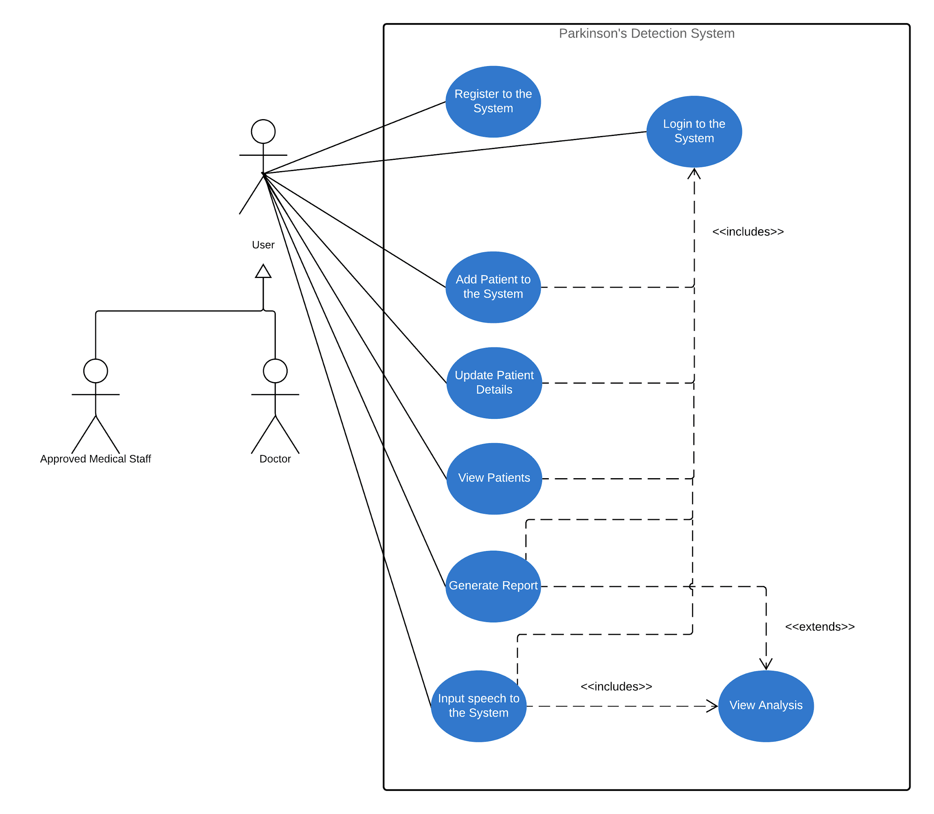

*Figure 4.3 - Use case Diagram*

## Use case description

### Use Case of Registering to the system

|  |  |
| --- | --- |
| **Use Case Name** | **Register to the System** |
| Description | Registering your name and details into the system to predict Parkinson’s disease. |
| Participating actors | Doctor/ Approved medical staff |
| Preconditions | 1) Make sure that the System is running. |
| Extended use cases | None |
| Included use cases | Login to the system |
| Main flow | 1) Enter the First name  2) Enter the Last name  3) Enter your Qualifications |
| Alternative flow |  |
| Exceptional flows | If there’s an error in any credentials, Displaying an error message. |
| Post conditions | Displaying a message That you have successfully registered into the system. |

Table 4.4.1.1 – Use Case for registering systems

### Use Case of Adding patients to the system

|  |  |
| --- | --- |
| **Use Case Name** | **Adding Patients** |
| Description | Adding name and details of the patient to check the voice recordings to detect Parkinson’s disease. |
| Participating actors | Doctor/ Approved medical staff |
| Preconditions | The user should be registered into the system. |
| Extended use cases | None |
| Included use cases | Login to the system |
| Main flow | 1) Entering the patient’s First name.  2) Entering the patient’s Last name. |
| Alternative flow |  |
| Exceptional flows | If there’s an error in any credentials Displaying an error message. |
| Post conditions | Displaying a message That you have successfully entered the details of the patient into the system. |

Table 4.4.2.1 – Use Case for adding patients

### Use Case of Updating patient details in the system

|  |  |
| --- | --- |
| **Use Case Name** | **Updating patient details** |
| Description | Updating the patient’s details that are already stored in order to detect Parkinson’s disease. |
| Participating actors | Doctor/ Approved medical staff |
| Preconditions | The Patient’s details should be stored in the system. |
| Extended use cases | None |
| Included use cases | Login to the system |
| Main flow | 1) Check for the patient’s name.  2) Select the patient’s details you want to update  3) Updating the details. |
| Alternative flow |  |
| Exceptional flows | If there’s an error in any credentials Displaying an error message. |
| Post conditions | Displaying a message That you have successfully updated the details of the patient in the system. |

Table 4.4.3.1 – Use Case for updating patient’s details

### Use Case of viewing patients

|  |  |
| --- | --- |
| **Use Case Name** | **Viewing Patients** |
| Description | Viewing patient’s details who are added into the system. |
| Participating actors | Doctor/ Approved medical staff |
| Preconditions | The Patient’s details should be stored in the system. |
| Extended use cases | None |
| Included use cases | Login to the system |
| Main flow | 1) Enter patient’s name  2) Select the correct patient name.  3) View details. |
| Alternative flow |  |
| Exceptional flows | If there’s an error in any credentials Displaying an error message. |
| Post conditions | Patient’s details and medications should be displayed. |

Table 4.4.4.1 – Use Case for viewing patients

### Use Case of Generating Reports

|  |  |
| --- | --- |
| **Use Case Name** | **Generating reports** |
| Description | Generating a report of the patients who were added into the system. |
| Participating actors | Doctor/ Approved medical staff |
| Preconditions | All the Details of the patients should be correct. |
| Extended use cases | View analysis |
| Included use cases | Login to the system |
| Main flow | 1) Check for the correct details.  2) Select generate report. |
| Alternative flow |  |
| Exceptional flows | If there’s an error in any credentials Displaying an error message. |
| Post conditions | Displaying the generated report of the patients who were added into the system. |

Table 4.4.5.1 – Use Case for generating reports

### Use Case of inputting Speech to the system

|  |  |
| --- | --- |
| **Use Case Name** | **Inputting speech** |
| Description | Inserting speech signals of the patients in to the system in order to detect Parkinson’s disease. |
| Participating actors | Doctor/ Approved medical staff |
| Preconditions | Patient’s details and credentials should be correct. |
| Extended use cases | None |
| Included use cases | Login to the system, View Analysis |
| Main flow | 1) Enter the name of the patient.  2) Making sure that the patient’s details are correct.  3) Inputting the voice dataset into the system. |
| Alternative flow |  |
| Exceptional flows | If there’s an error in any credentials Displaying an error message. |
| Post conditions | Displaying a message That you have successfully inserted the speech dataset of the patient into the system. |

Table 4.4.6.1 – Use Case for inputting speech to the system

## Activity Diagram

### Add patient

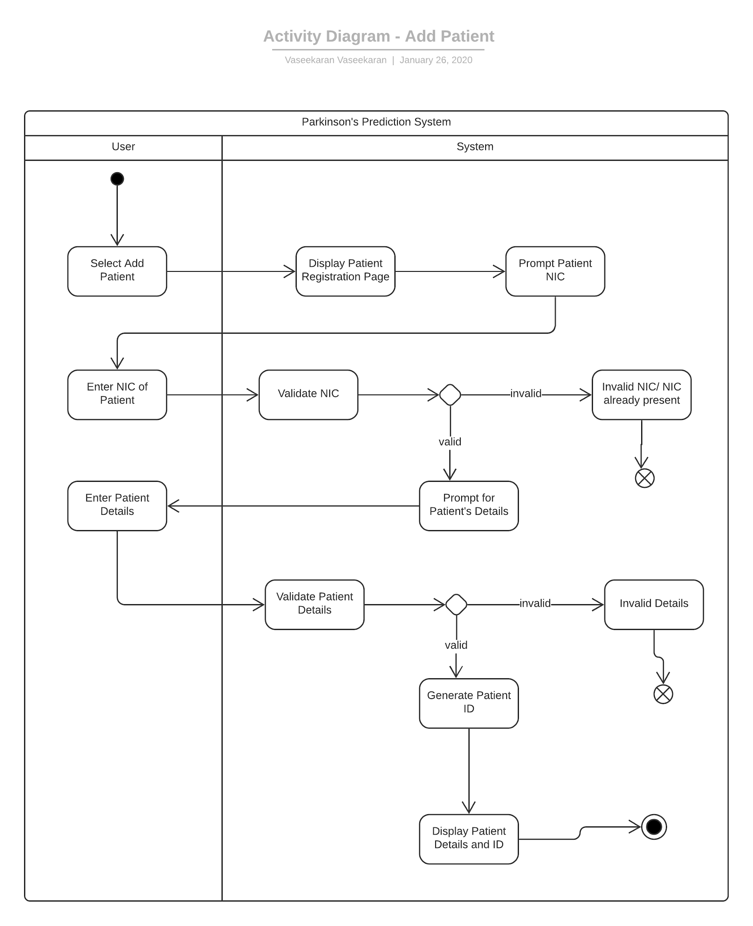

*Figure 4.5.1 - Add Patient*

### Input speech to the system

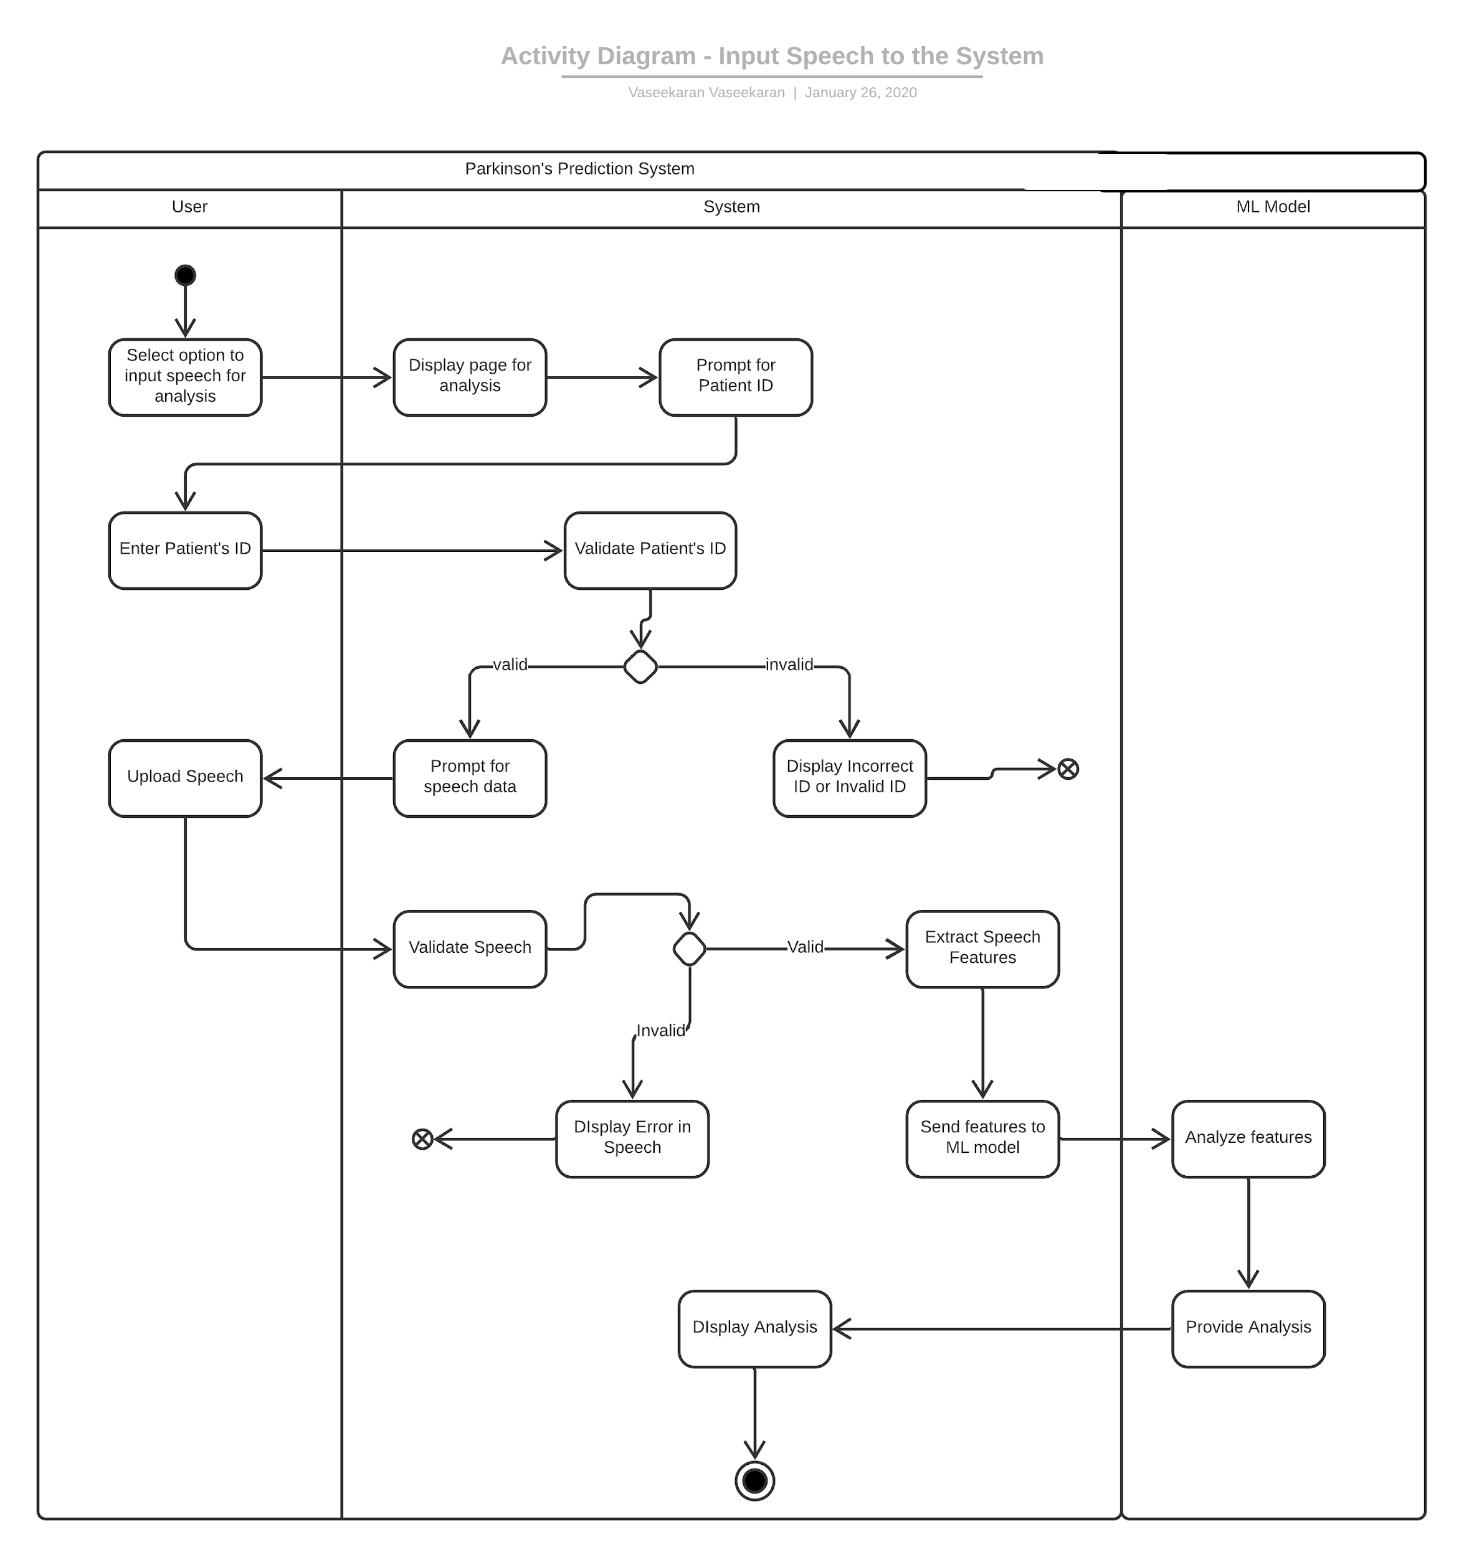

*Figure 4.5.2.1 - Input speech to the system*

### Login

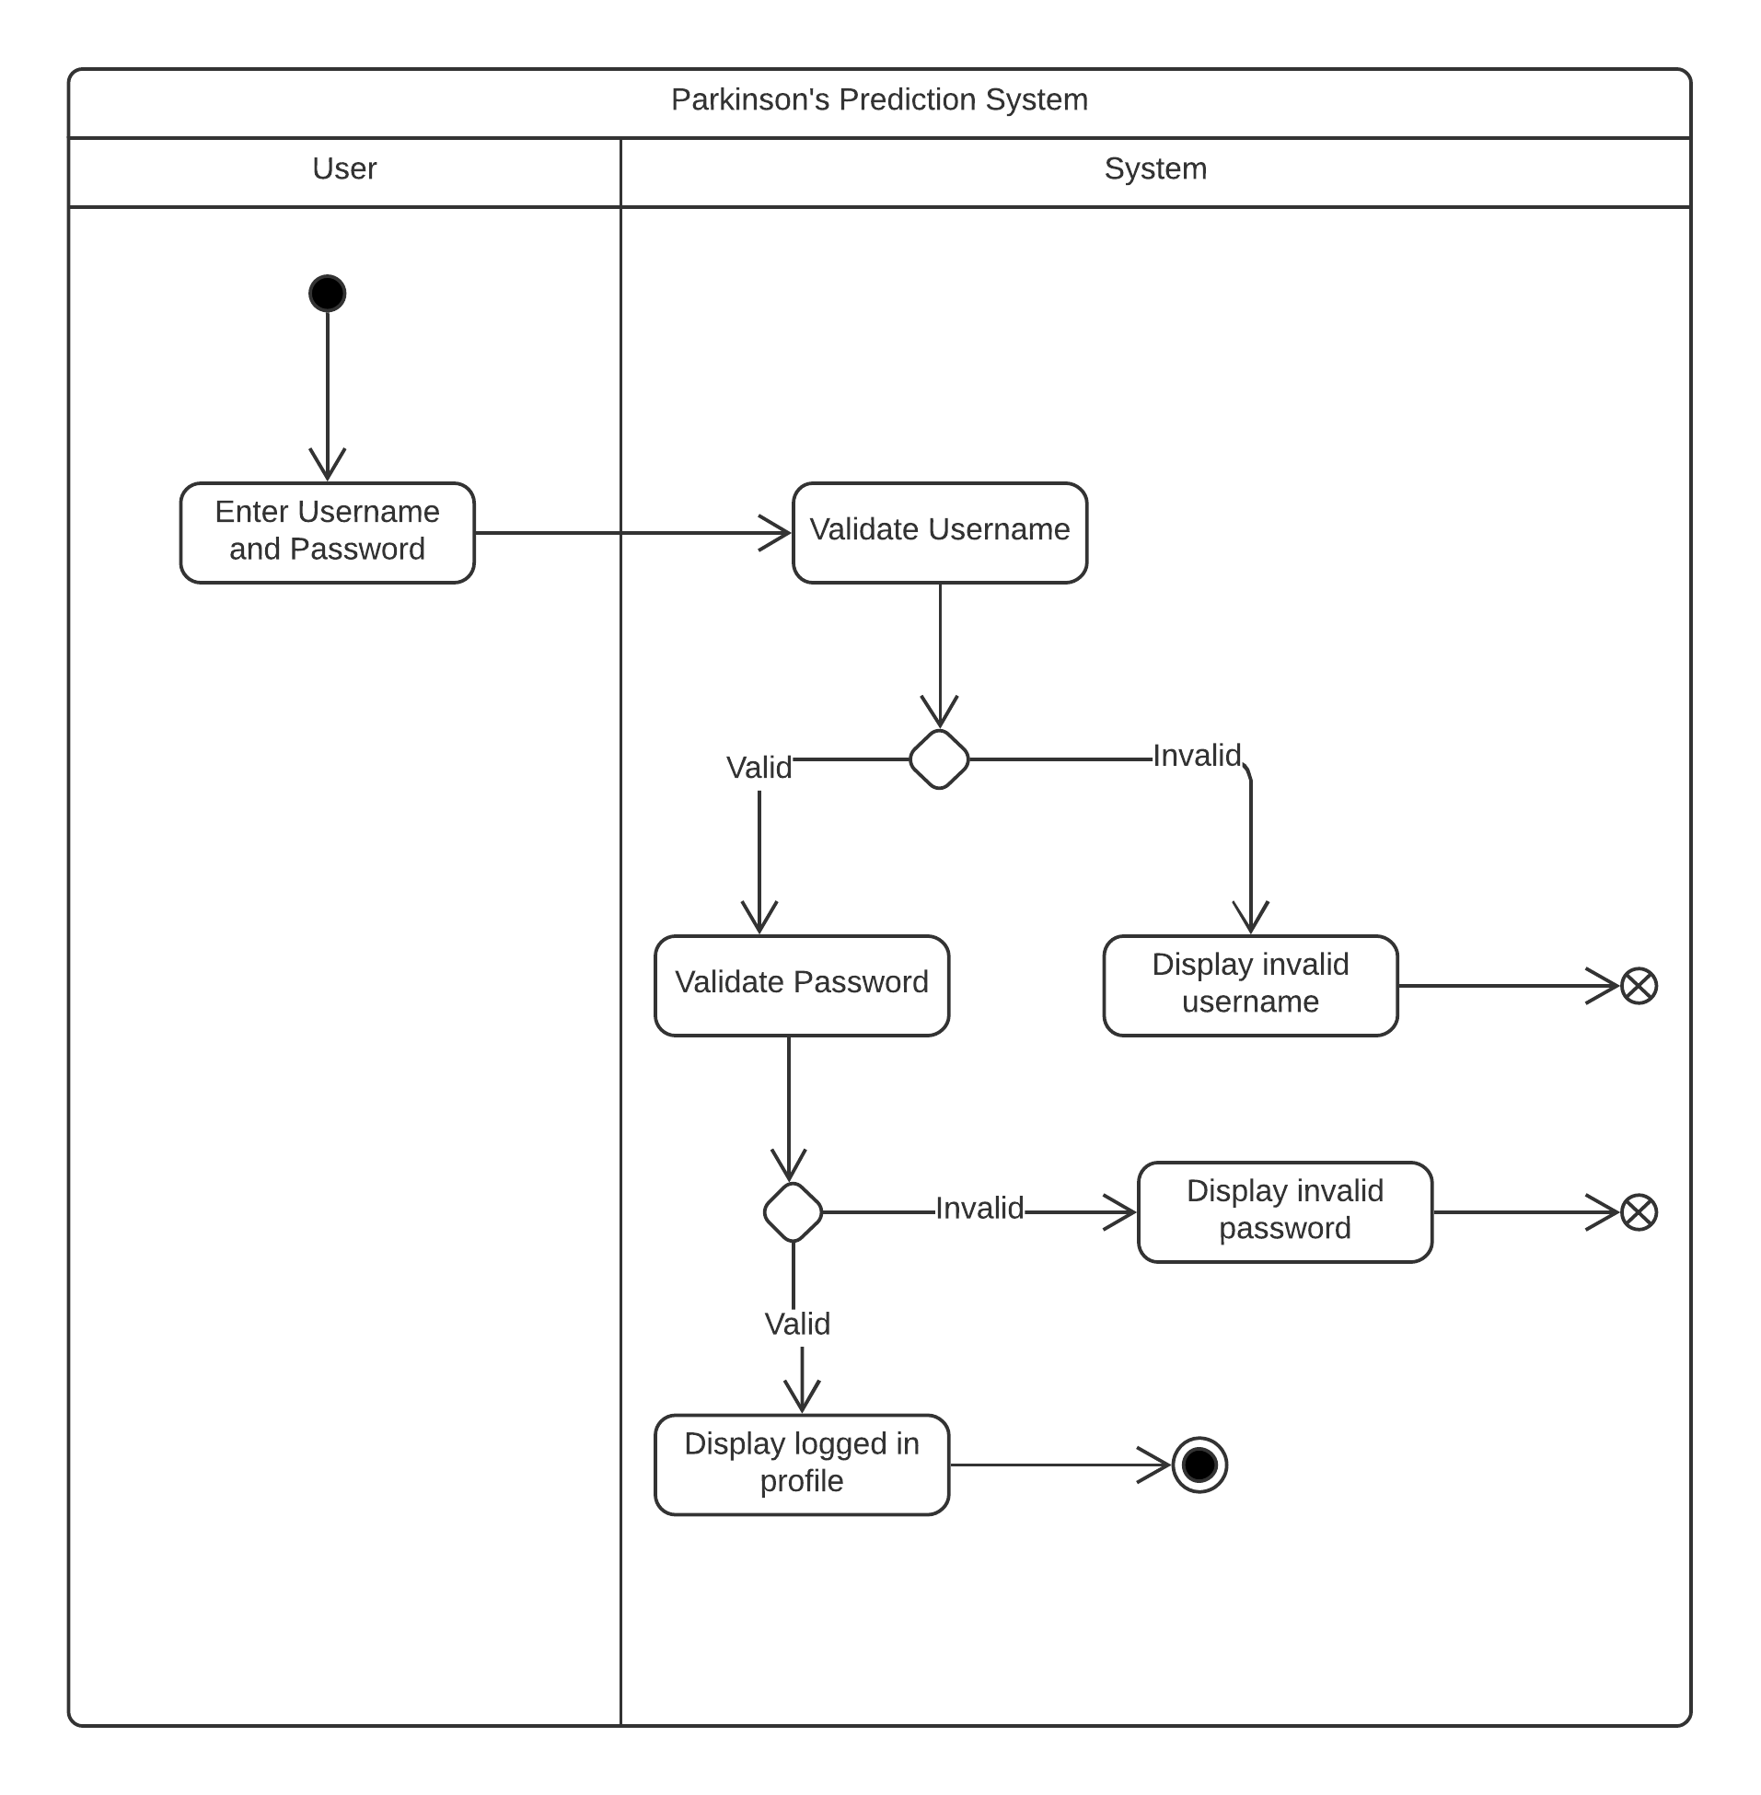

*Figure 4.3.3 - Login*

### Registration

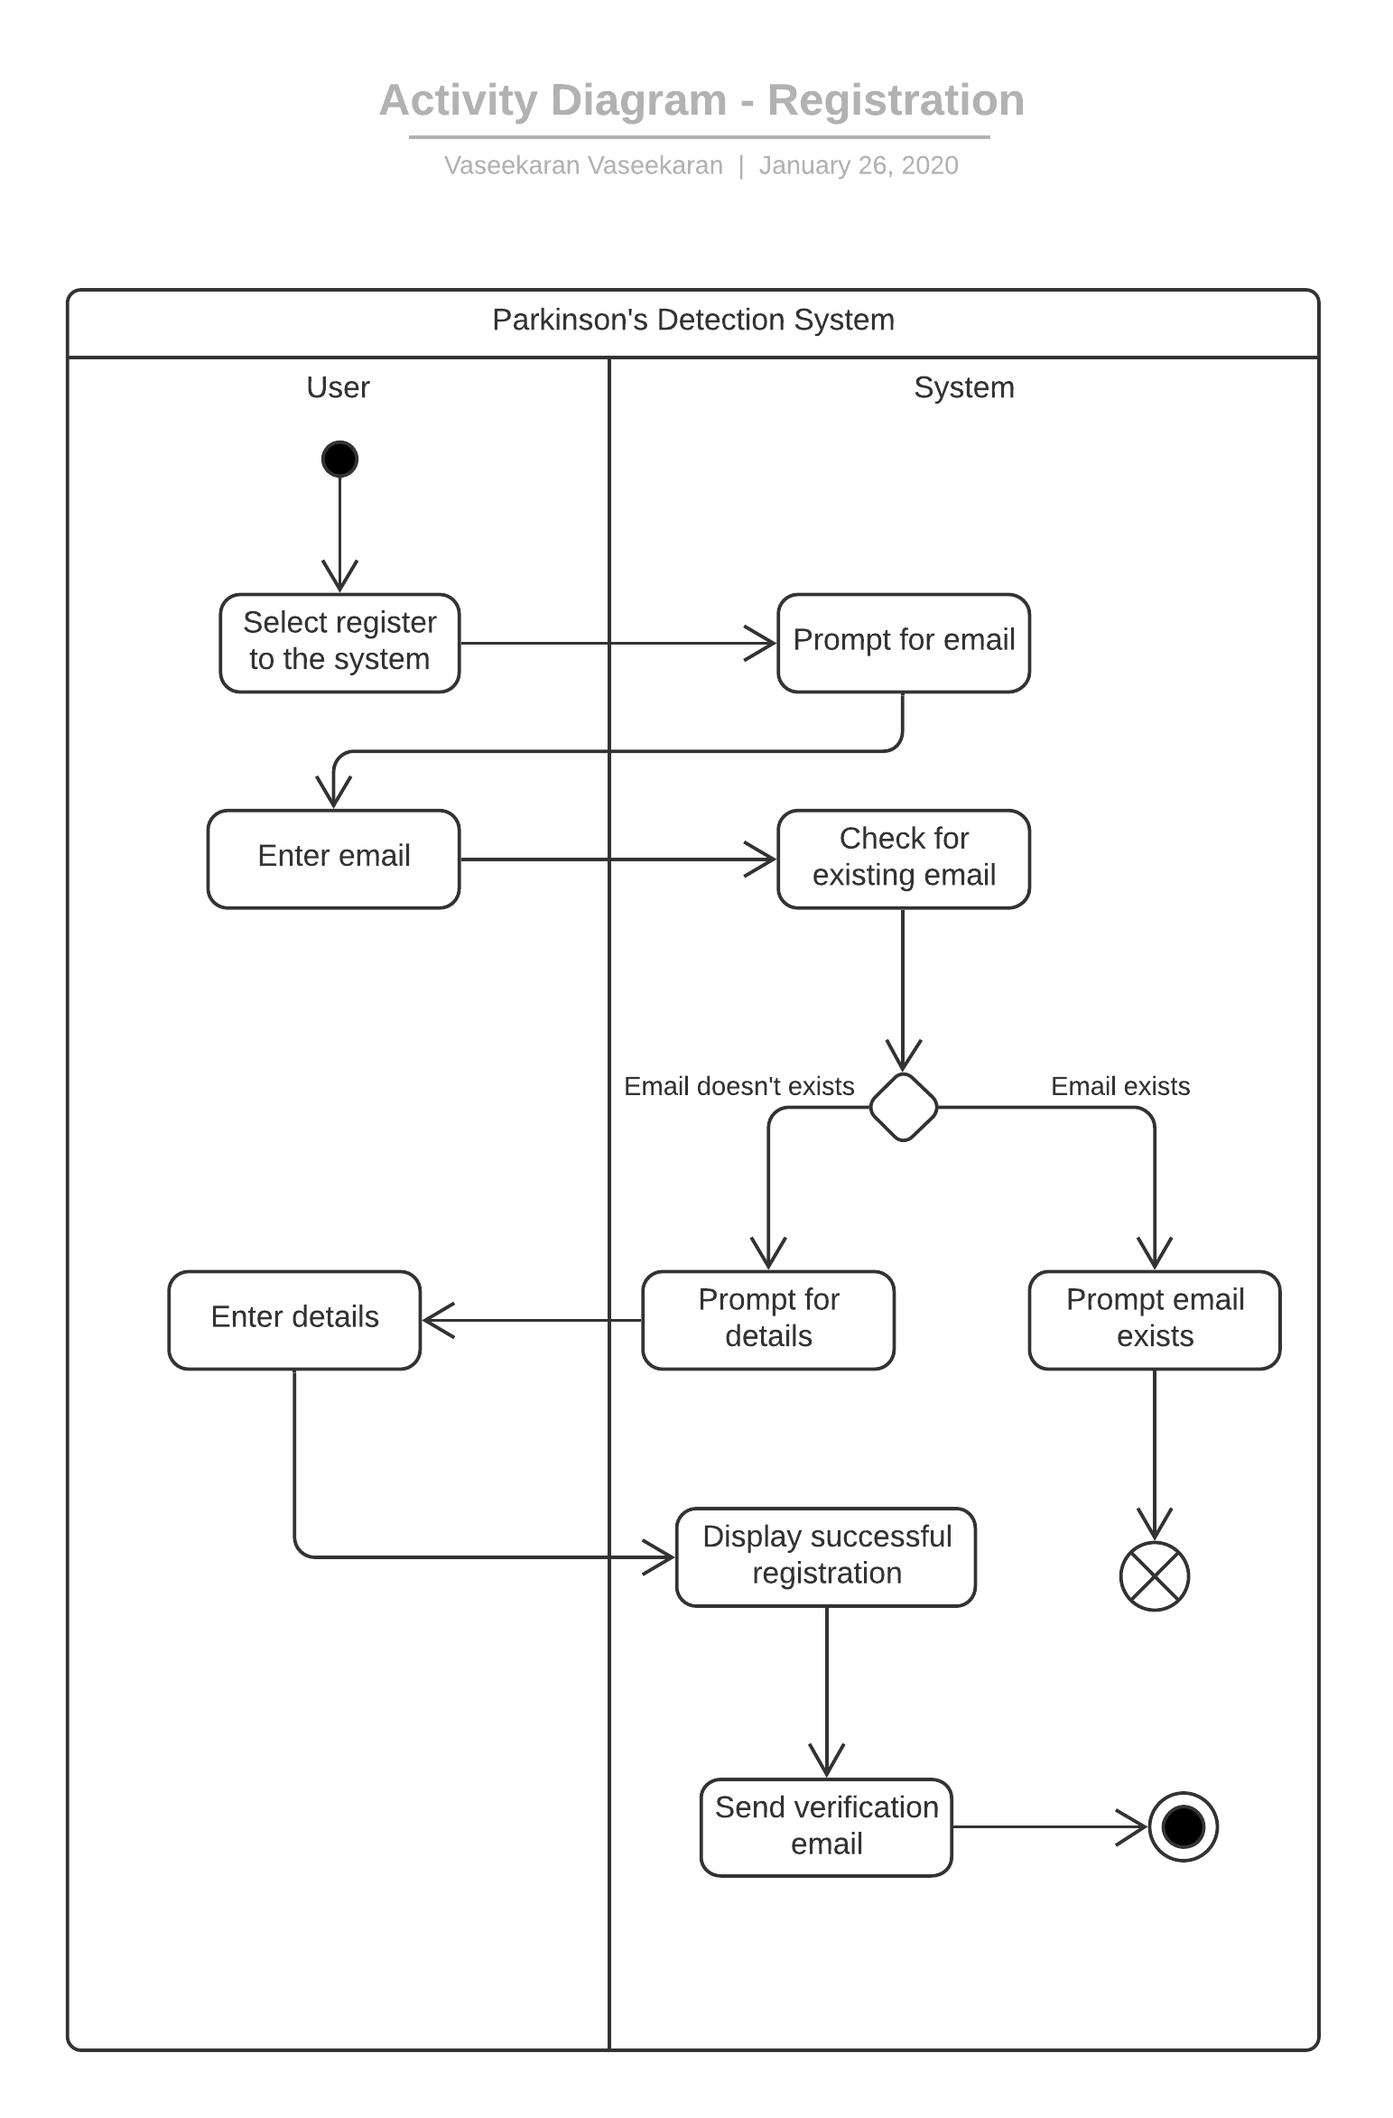

*Figure 4.5.4 - Registration*

## Stakeholder Analysis

*Figure 4.6 - Stakeholder analysis*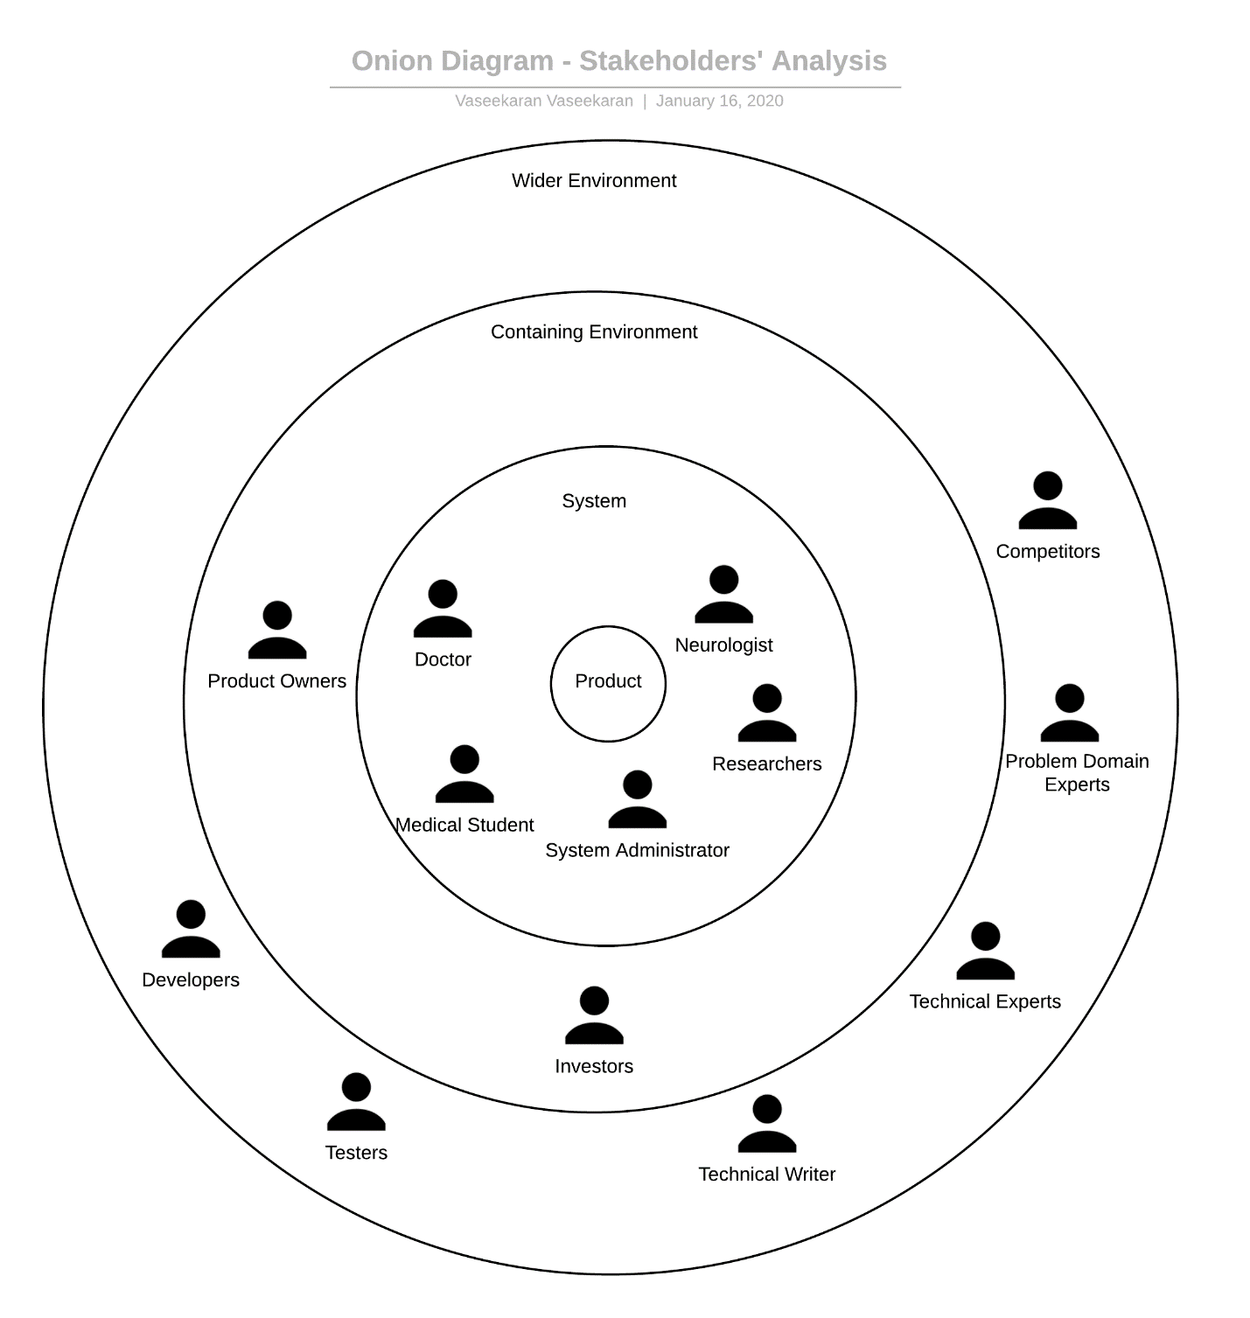

|  |  |  |
| --- | --- | --- |
| **Stakeholder** | **Role** | **Benefits** |
| Doctor  Neurologist  Medical Student  Researcher | Operational - Maintenance | Detect abnormalities in speech and predict whether Parkinson’s is present, using the system. |
| System Administrator | Operational - Administration | Maintains the system by installing, monitoring and upgrading the software. |
| Product Owners | Functional Beneficiary | The owner for whom the software for predicting Parkinson’s is developed for. |
| Investors | Financial Beneficiary | Invests to make profits and increase the user base. |
| Problem Domain Experts | Expert | Provide expert knowledge on the problem domain, that is on Parkinson’s. |
| Technical Experts | Expert | Provides expert knowledge on the technologies and methodologies that can be utilized for the project |
| Technical Writer | Operational - Support | Creates the documentation for the system. |
| Developers | Financial - Beneficiary | Creates the system |
| Testers | Quality Regulator | Tests the system before deployment to ensure maximum quality. |
| Competitors | Negative Stakeholders | Creates system that has features directly related to the proposed product, which creates competition. |

*Table 4.6.1 - Stakeholder analysis*

## Requirement Specifications

Under this section, the requirements of the system are identified and prioritized according to these levels.

|  |  |
| --- | --- |
| **Priority Level** | **Description** |
| Critical | Core functionality of the system |
| Important | Not essential, but necessary |
| Desirable | Not necessary, but a feature that would beautify/strengthen the system. |

*Table 4.7.1.1 - Requirements specifications*

### Functional requirements

|  |  |  |  |
| --- | --- | --- | --- |
| **#** | **Requirement** | **Description** | **Priority Level** |
| FR1 | Must analyze the speech of the patient | The system should analyze the speech of the patient that was input by the doctor and provide accurate predictions. | Critical |
| FR2 | Register and login to the system | The doctor should be able to register and log in to the system, in order to use it. | Important |
| FR3 | Add and Update Patient Details | The doctor should be able to add and update patient details in the system; the patients are the ones whom the doctor is going to diagnose for Parkinson’s Disease. | Important |
| FR4 | View Patient’s Details | The doctor should be able to view the diagnosis reports of the patients for further diagnosis or prescriptions. | Important |
| FR5 | Bridge the Language Gap when designing the User Interface | The interface could be designed with all the 3 languages (English, Sinhala and Tamil), therefore the user won’t have any problems in using the system. | Desirable |
| FR6 | An introductory session for the user | There could be an introductory session for the user by helping him to get familiarized with the system. | Desirable |
| FR7 | Dark mode | Adding a Dark Mode for the system could help the user when using the system in low light and also beautify the UI of the system. | Desirable |

*Table 4.7.2.1 - Functional requirements*

### Non-functional requirements

|  |  |  |  |
| --- | --- | --- | --- |
| **#** | **Requirement** | **Description** | **Priority Level** |
| NFR1 | Accuracy | The system should accurately predict whether a patient has Parkinson’s. | Important |
| NFR2 | Performance | The system should present the predictions in a short time. | Important |
| NFR3 | Maintainability | The system should be designed in a way that is easy to add features or remove bugs without major issues. | Important |
| NFR4 | Usability | The system should be simple and clear enabling it to be used by anyone without an IT background. | Important |
| NFR5 | Security | The system should be secure in order to protect and preserve the Doctor and Patient details that it is storing | Important |
| NFR6 | Maintainability | Sufficient and clear documentations should be present in order for the new developers or testers to be familiarized with the system easily. | Important |

*Table 4.7.3.1 - Non-functional requirement*

### Chapter Summary

Under this chapter, various ways that was used to gather the necessary requirements to successfully build the system was discussed, and the advantages and disadvantages in each method was seen. The use case diagram was displayed, which represents a clear idea of the product. Activity diagrams were drawn too, in order to provide a clear representation of some of the use cases of the system. Finally, stakeholder analysis was done, analyzing each and stakeholder who could possibly affect the system.

# Design

## Chapter Overview

This Chapter focuses on the Design aspects of the system. It covers design decisions as well as diagram used in creating the system. The design diagrams involved are High level, low level designs, system architecture, class diagram, System process flow diagram, sequence diagram and UI wireframes.

## Design Goals

|  |  |
| --- | --- |
| **Design Goal** | **Description** |
| Correctness | The predicted results should provide the correct predictions whether the person has Parkinson’s disease or not up to a certain good accuracy level |
| Performance | Process of Predicting the results should be within a minimum time. |
| Security | Since the data is regarding patients, the security of data access should be high to reduce ethical risks. |

*Table 5.2 .1- Design goals*

## Rich picture diagram

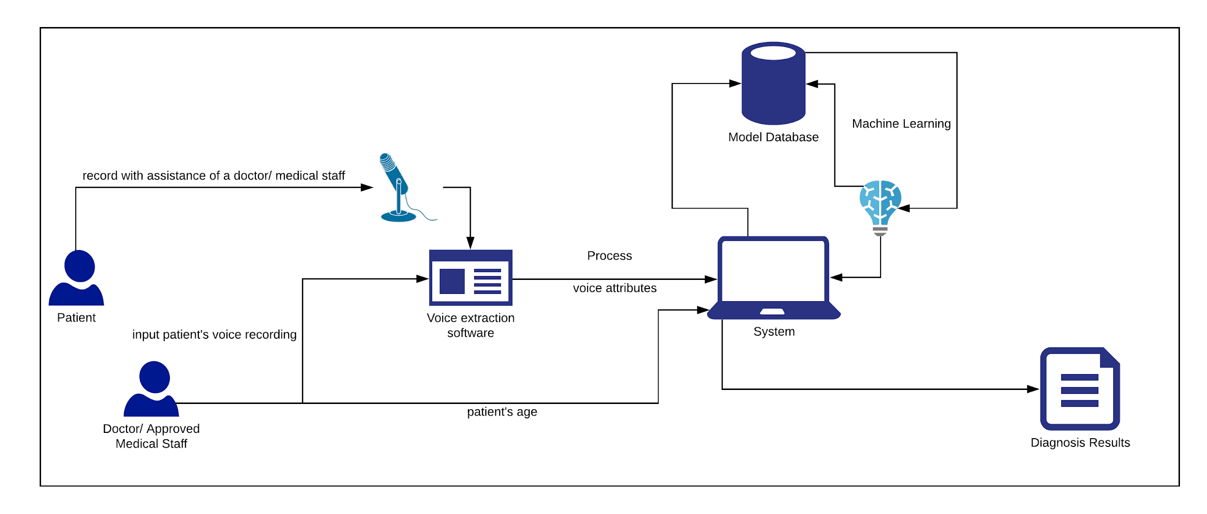

*Figure 5.3 - Rich picture diagram*

The user obtains the input speech data to the system, and then the system processes the input data with the help of using the Machine Learning algorithm. Diagnosis is performed and a detailed analysis would be generated by the algorithm, and the result would be sent to the system and the user would be able to view the generated result and decide based on the analysis.

## Machine Learning Design

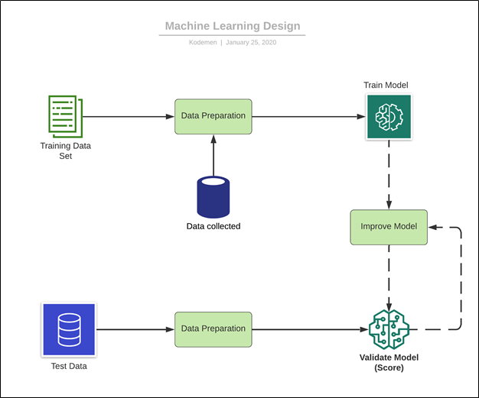

*Figure 5.4 - Machine learning design*

Above is a representation of how our intended model for Machine Learning would be trained. Initially, the data from the training dataset would be extracted and would be used to train the model and then would be improved. The data which we are collecting (i.e. the speech data of native patients affected by Parkinson’s disease) would be used to train the model. Then the model’s accuracy would be calculated and then improved until the accuracy is high.

In order to test the model’s validity, test dataset would be used to validate the model and check for any bugs/inaccuracies.

## High level architecture diagram

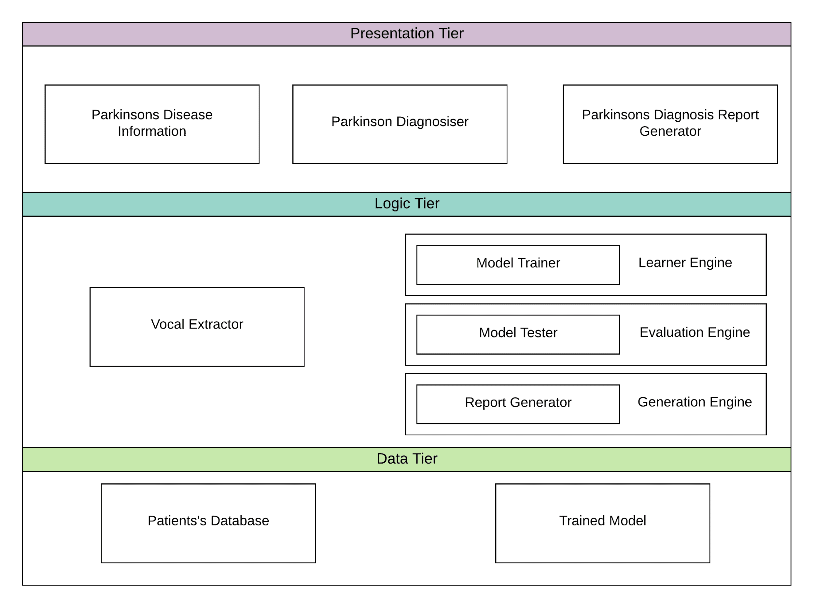

*Figure 5.5 - High level architecture diagram*

In the presentation tier, three components are given. They are

* Parkinson’s Disease Information – This component gives information and news feed about Parkinson’s Disease.
* Parkinson’s Disease Diagnosis – This component is about inputting speech and finding out the diagnosis results
* Parkinson’s Diagnosis Report Generator – Used to generate a report of the person including patient ID and their diagnosis results.

The core components of the logic tier are given below,

* Vocal Extractor – Using a voice analyzing API to analyze the patient’s speech and get the attributes
* Model Trainer – To train the model with person with and without Parkinson’s disease
* Model Tester – To test whether the, the results correct and accurate.
* Report Generator – To generate report of person’s diagnosis results

The components in the Data Tier are,

* Patients’ Database
* Trained Model

## Class Diagram

The Class Diagram for our system contains of 9 classes, where the 4 main classes are the VoiceParameter, Logger, Database (for connection), and User. VoiceParameter class has a composition relationship with 5 classes: Pulse, Voice, Pitch, Harmonicity, and Frequency, which makes up the VoiceParameter class.

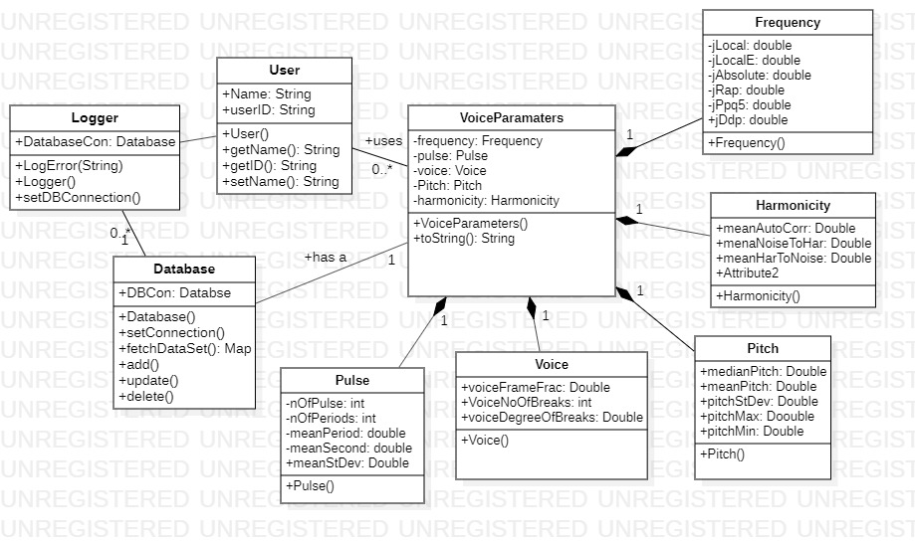

Figure 5.6.1 – Class Diagram

## System process flow diagram

*Figure 5.7.1 - System process flow diagram*

The flow chart given above visualizes the workflow of the core functionality that is the machine learning, and the components engaged with machine learning process.

## Sequence Diagram

### Sequence Diagram for Inputting Speech and ML results

The below sequence diagram depicts the communication that occurs in between speech input of the patient and user getting the diagnosis results. The speech analyzing application is connected through API to get phonetic attributes to the web application. So after inputting the speech, the ML will be done inside the web Application with the help of database and then the user will get diagnosis results.

*Figure 5.8..1 - Sequence Diagram for Inputting Speech and ML results*

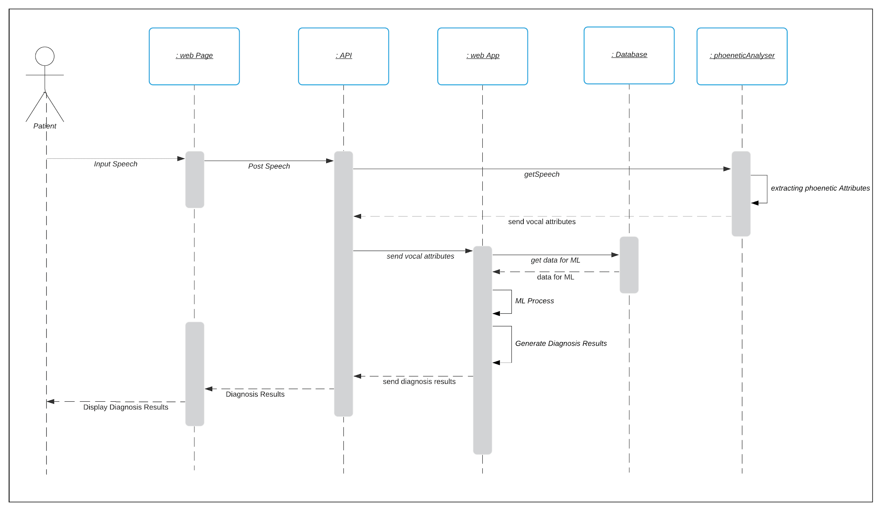

### Sequence Diagram for Registering Patient

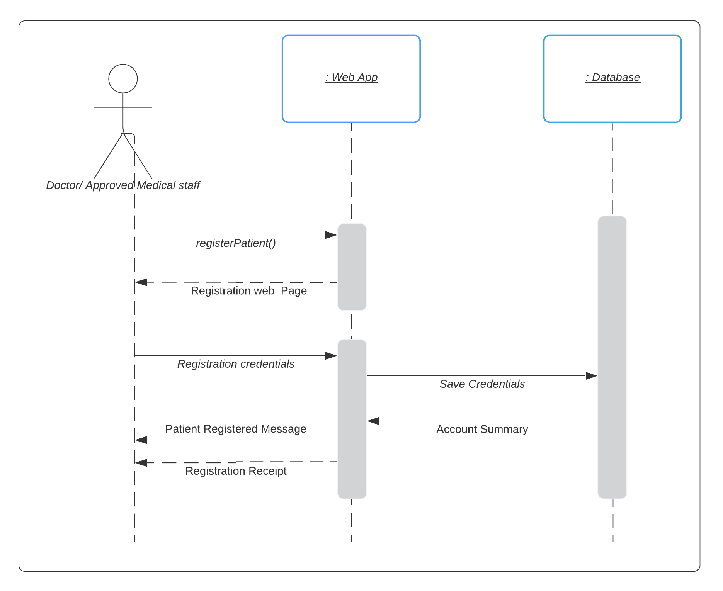

*Figure 5.8.2.1 - Sequence Diagram for Registering Patient*

The above sequence diagram shows the communication done when registering a patient. First of all, to register the patient, the user who can be a doctor or approved medical staff should be logged into their profiles. After logged in, the patient will be registered to the system and the patient will be given a unique patientID.

### Sequence Diagram for Registering User

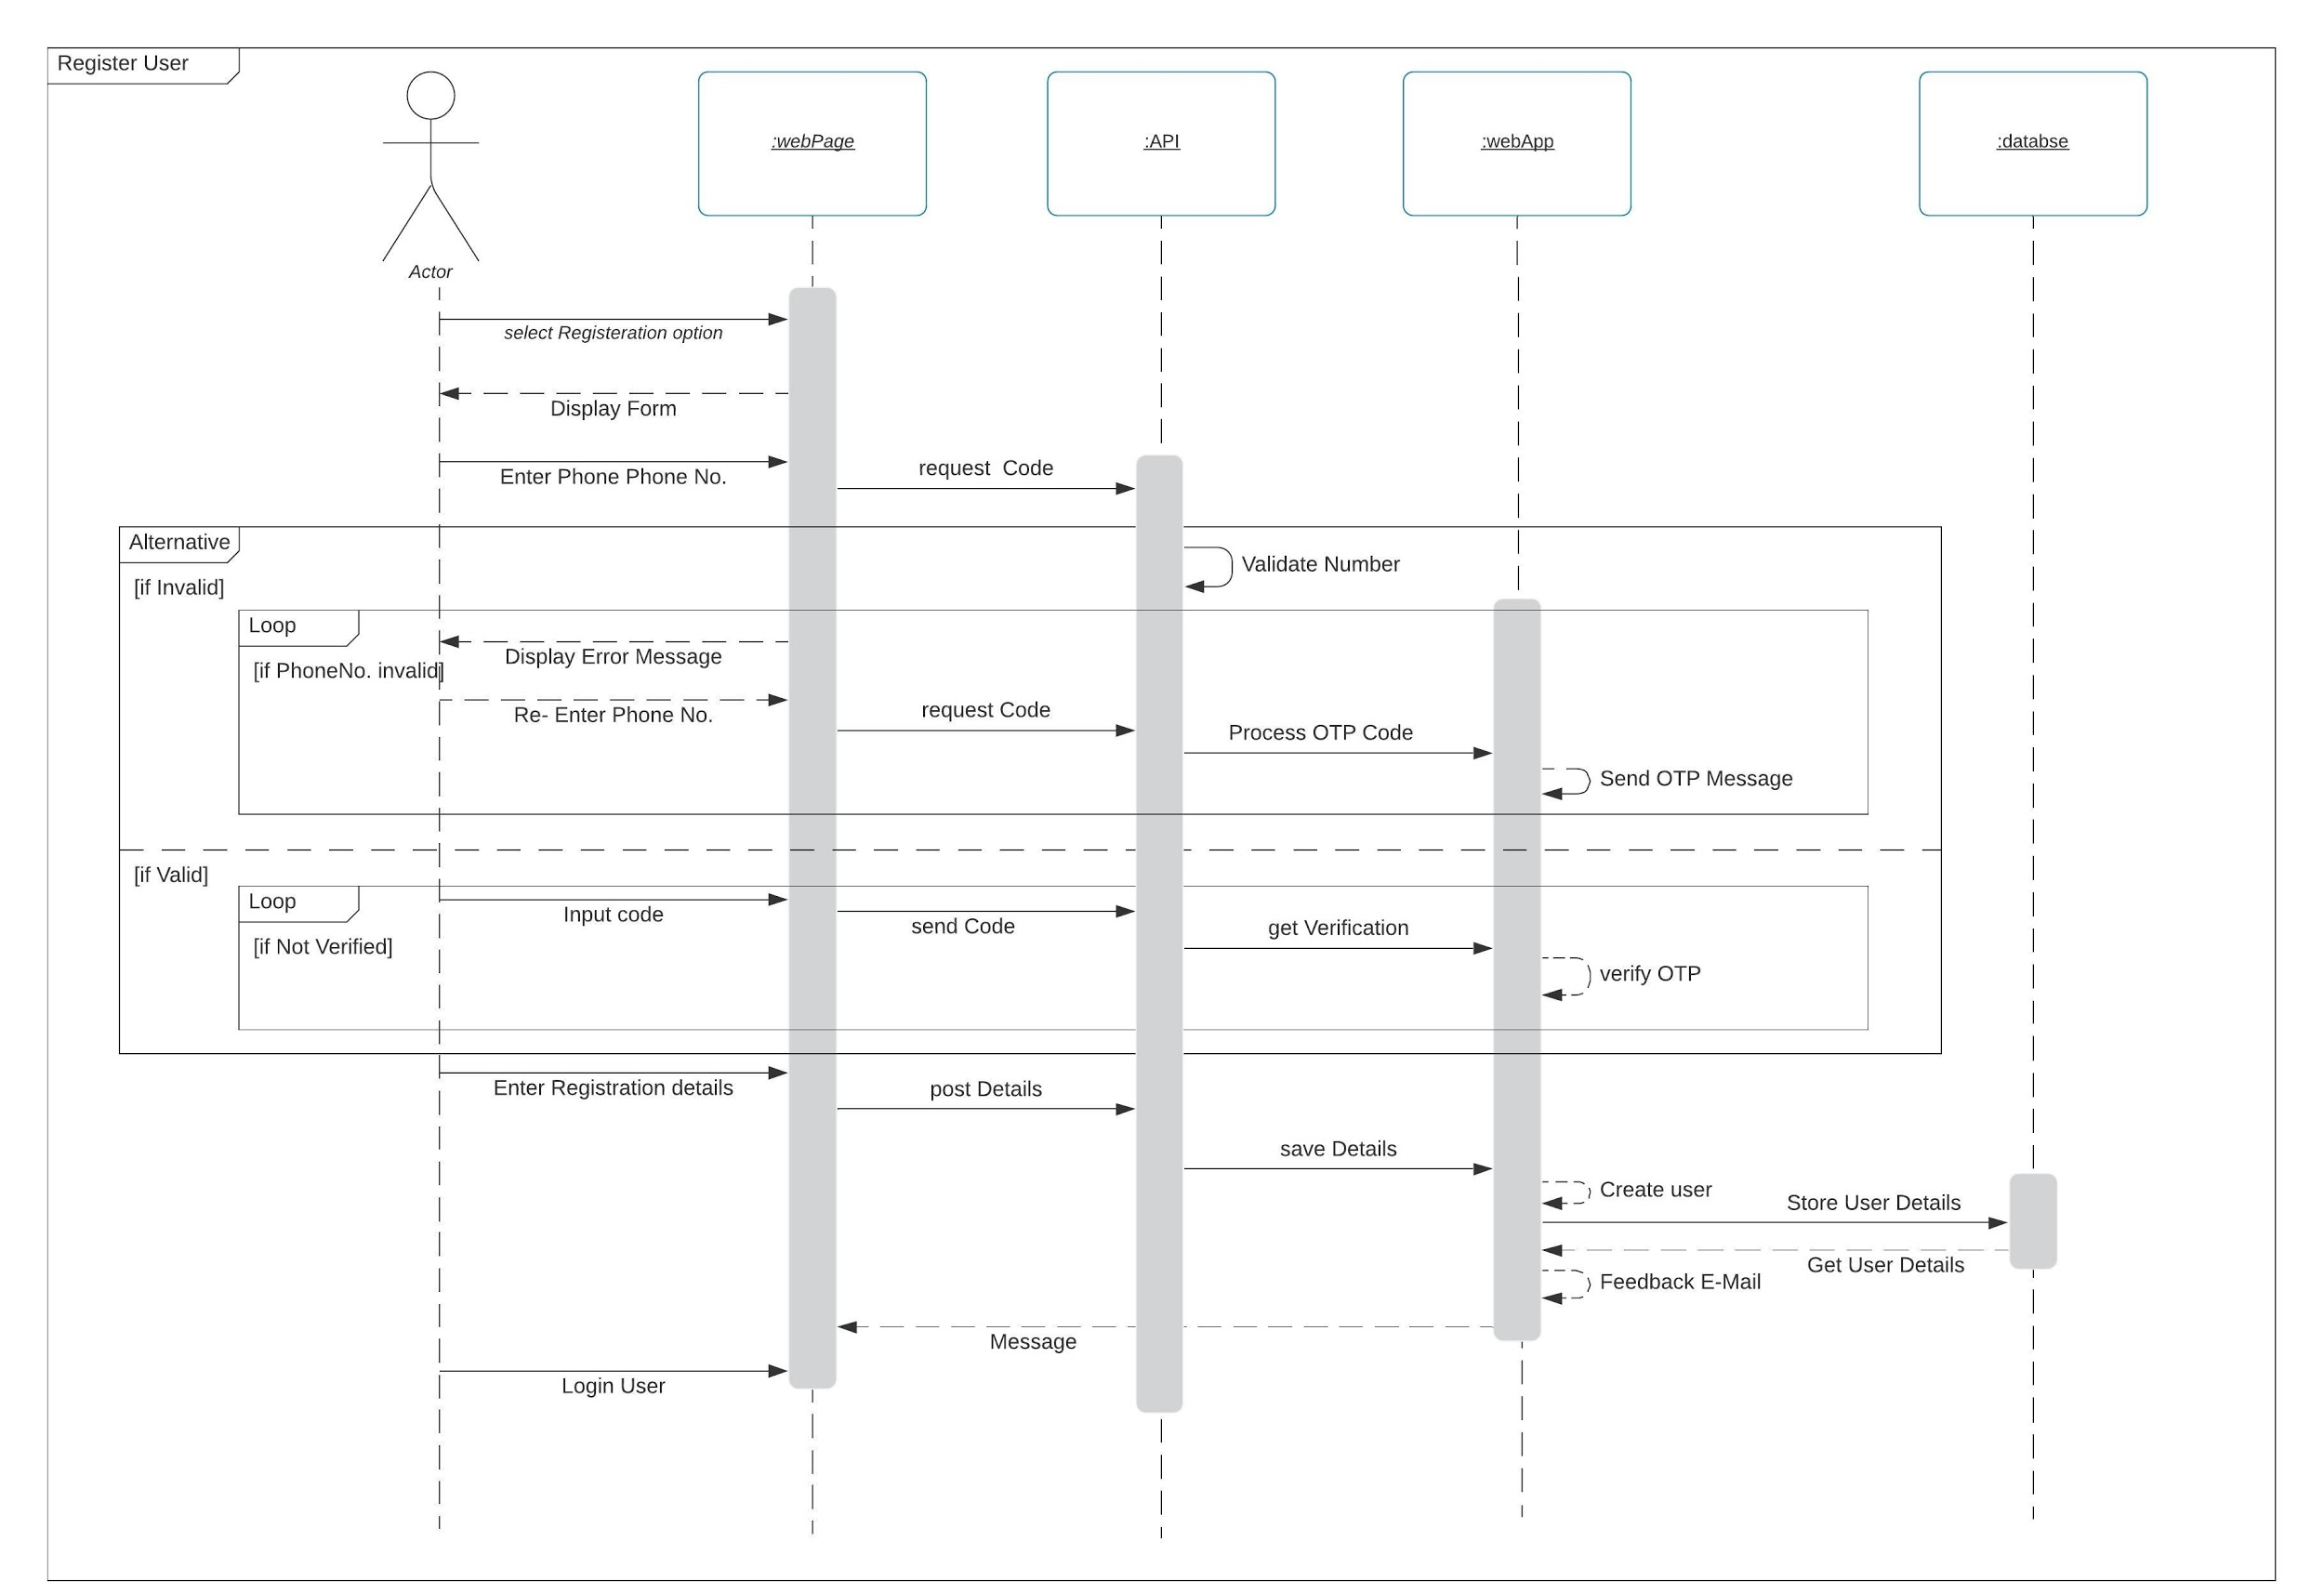

*Figure 5.8.3.1 - Sequence Diagram for Registering User*

### Sequence Diagram for login for user

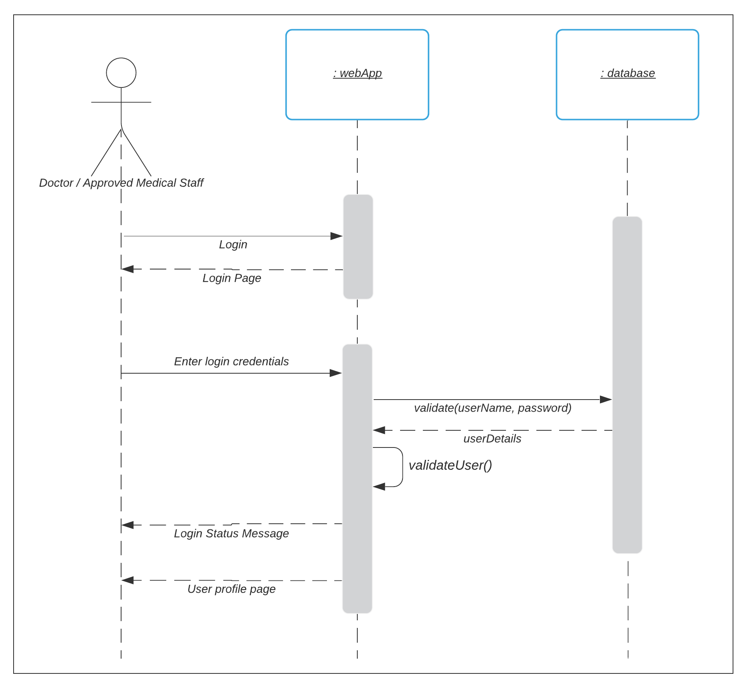

*Figure 5.8.4.1 - Sequence Diagram for Login*

### Sequence Diagram for viewing patient detail

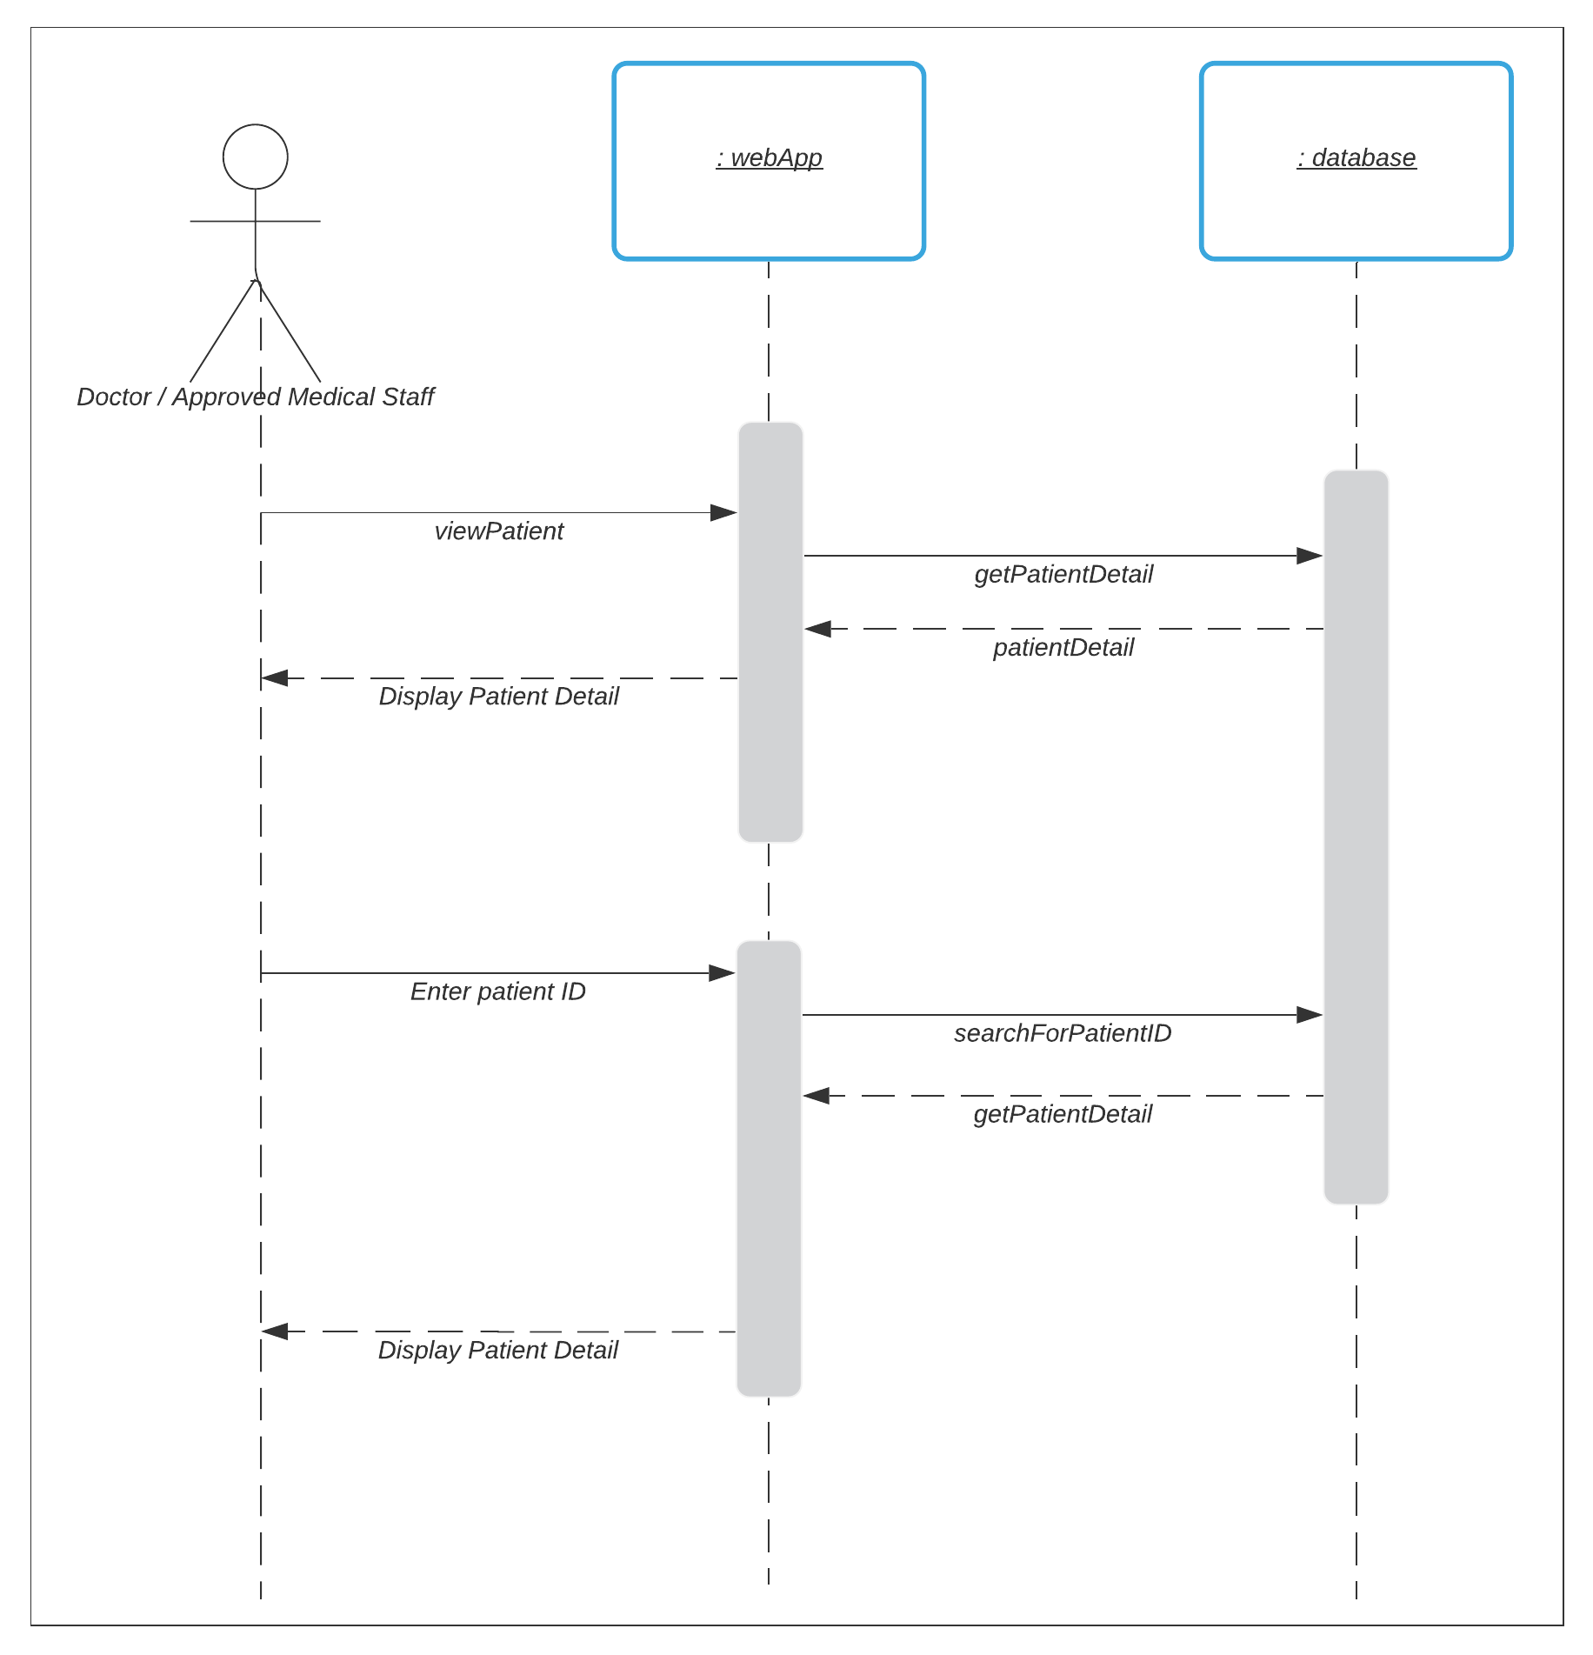

*Figure 5.8.5.1 - Sequence Diagram for Registering Patient*

## Chapter Summary

This chapter documented the design components of the system. Design goals were clarified initially. Then rich picture diagram is given visualizing the core functionality of the system. Machine Learning Design and High Level architecture design is given visualizing the ML process and Phases of the system respectively. Class diagram is designed to implement the core functionality of the system. Then System process flow and sequence diagram is documented to indicate the workflow and sequential communication between the components. Finally UI wireframes are designed as well.

# Implementation

## Chapter Overview

This chapter covers the implementation of the proposed system. Identifying the suitable language and the development tools are documented. Then the libraries/ frameworks selection and APIs are documented. Also the selected datasets were discussed.

## Technology selection

### Language Selection

The languages that we used to develop the system were Python and R. Python is a perfect choice for machine learning and data science. It is a minimalistic and intuitive language with a full-featured library line. And also we used it for developing the back end and RESTful API service. R is used to develop machine learning programs. Any techniques for data analysis, sampling, visualization, supervised learning and model evaluation are provided in R and also it is an open source software and runs on any workstation platform.

For the front end development Angular was chosen. Angular is a web development platform built in TypeScript that provides developers with robust tools for creating the client side of web applications.

### Libraries/ Frameworks selection

Angular is used in front-end development. It is specialized in building rich single-page applications. Bootstrap is selected for developing responsive websites. It is a most popular CSS Framework for developing responsive and mobile-first websites. It saved us from writing lots of CSS code.

## Dataset

## Implementation

### Front-end

### Machine Learning Engineering

#### **OBTAINING THE DATA**

Each recording of the patients was taken carefully: a sound-proofed room was provided by the hospital. Microphone was used to record the audio and the patient was required to repeat the sounds such as sounds of the vowels and were required to read some sentences. Then, Praat software was used to extract the acoustic features from the sound that was recorded.

#### **FEATURE SELECTION**

In creating a suitable machine learning model, the most important step is selecting the features that need to be analyzed in order to obtain an accurate model. The features that have to be analyzed are:

* Jitter
  + local
  + Local, absolute
  + rap
  + ppq5
  + ddp
* Shimmer
  + local
  + apq3
  + apq5
  + apq11
  + dda
* AC
* NDH
* HTM
* Pitch
  + Median
  + Mean
  + Standard Deviation
  + Minimum
  + Maximum
* Periods
  + Number of pulses
  + Number of periods
  + Mean
  + Standard Deviation
* Fraction of locally unvoiced frames
* Number of voice brakes
* Degree of voice breaks
* Status

Other than the feature **status**, other features are the features of the voice that are extracted. Praat software was used in order to extract the features. The status feature is the dependent variable: which indicates whether the row (audio extracted from patient) is diagnosed with Parkinson’s disease or not.

Feature selection is critical in order to create the model. As it can be seen in the features, Jitter and Shimmer are measured in different scales (local, ppq5, apq5, etc.). Including all of those features would severely affect the model, as each scale basically measures the same feature. Therefore, one scale of measurement from Jitter and one scale of measurement from Shimmer is selected in order to develop the model, and after the development, then another pair from Jitter and Shimmer are selected and the model is developed, and this steps are continued until all the scales of Jitter and Shimmer are analyzed. When considering the Pitch feature, it has 2 different measurements of locations: mean and median. Therefore, again one of the features is used for development and then the other is selected for another development. Standard deviations of both Pitch and Period are dropped. 2 examples of how the features are selected and grouped are given:

* **'Jitter(local, absolute)','Shimmer (dda)'**,'AC', 'NDH', 'HTM', '**Mean Pitch**', 'Minimum pitch', 'Maximum pitch', 'Number of pulses', 'Number of periods', 'Mean period' , 'Fraction of locally unvoiced frames', 'Number of voice breaks', 'Degree of voice breaks'.
* **'Jitter(ddp)','Shimmer (apq11)'**,'AC', 'NDH', 'HTM', '**Median Pitch**', 'Minimum pitch', 'Maximum pitch', 'Number of pulses', 'Number of periods', 'Mean period', 'Fraction of locally unvoiced frames', 'Number of voice breaks', ‘Degree of voice breaks ’.
* **The above feature selections are just 2 of the selections that are considered. The total possible number of groups of features selected:**

**5C1 * 6C1 * 2C1 = 60 possible combinations of features**

Since features from many different measurements are present, it would be unwise to input then directly as it would cause complications. Therefore, the features are scaled in order to output effective results. The function StandardScaler (makes the distribution’s mean and standard deviation as 0 and 1 respectively, i.e. a normal distribution) and MinMaxScaler (transforms each value within the range from 0 to 1 and preserves the shape of the initial distribution).

#### **MACHINE LEARNING ALGORITHMS**

##### **CLASSIFICATION**

The objective of the machine learning model is to detect whether a patient is diagnosed with Parkinson’s or not. Therefore, this is a classification problem. Currently, there are many traditional algorithms that can be used for classification and those algorithms are implemented for each feature group that was extracted in the feature engineering section. The algorithms are:

* Logistic Regression
* Decision Tree Classifier
* Gradient Boosting Classifier
* k-Nearest Neighbors classifier
* Random Forest Classifier
* Support Vector Machines
* XGBoost (extreme Gradient Boosting) algorithm

Also, a deep learning method: Artificial Neural Network is implemented too.

Before training the model, the dataset for training was split into training set and testing set. Training set is used to train the machine learning model with the algorithm, and the testing set is to test the predictions that can be obtained using a trained model and to cross-check the predictions made by the model. As a general rule of thumb, the dataset was split in 80:20, where 80% is the training set and the 20% is the testing set. A total of 1036 rows exist; therefore, it creates a training set of about 828 samples and a testing set of about 208 samples.

Since features from many different measurements are present, it would be unwise to input then directly as it would cause complications. Therefore, the features are scaled in order to output effective results. The function StandardScaler (makes the distribution’s mean and standard deviation as 0 and 1 respectively, i.e. a normal distribution) and MinMaxScaler (transforms each value within the range from 0 to 1 and preserves the shape of the initial distribution).

###### **MACHINE LEARNING ALGORITHM ANALYSIS FINDINGS**

**LOGISTIC REGRESSION**

Logistic regression can be stated as the basic classification algorithm in Machine Learning and it provides a linear classification. The library, sci-kit learn of python provides machine learning algorithms that can be directly used, and logistic regression is present in the library. Models created here use a set of features and the entire features depicted model with high bias compared to models that would be discussed later. Therefore, logistic regression was rejected.

**k-NEAREST NEIGHBORS**

KNN is another supervised machine learning algorithm that classifies a data point based on how its neighbors are classified. Validation was used in order to determine what best accuracy could be obtained with the best value for k (between 1-100). And then, the model was created using the sci-kit library and the training and test sets accuracies were recorded. KNN performed well. Using the entire features, the training set accuracy and test set accuracy are at around 73%. Therefore, k-Nearest Neighbors classification model can be used for prediction.

**DECISION TREES**

Decision Trees is a machine learning classification algorithm that takes the target variable as categorical variables (Classification Trees). Here, the sci-kit library is used in order to obtain the classifier model. Testing the model with the entire features gave a training set accuracy of 0.92% and a test accuracy of 0.60%. Here, it can be seen there is a high variance in the test set accuracy, therefore overfitting the model. When selecting group-wise (as mentioned in the feature selection section), the model did not show any improvement, as it still severely overfits. Therefore, Decision Trees classification was rejected.

**GRADIENT BOOSTING**

Gradient Boosting model is a supervised machine learning algorithm that can be used for classification purposes, and this model creates a prediction model in the form of a collection of weak prediction models, like the decision trees. Models were created using the sci-kit library and initially a model was created by fitting the entire features. It had a high training set accuracy of 0.89 but a significantly lower test-set accuracy of 0.74. This clearly indicates overfitting of the model. Also, grouping features as mentioned in feature selection did not provide any improvement, as overfitting was visible throughout the results. Therefore, the Gradient Boosting algorithm cannot be accepted as a valid model for the dataset and was rejected.

**RANDOM FORESTS**

Random Forests is a popular machine learning algorithm, known for its accuracy, and performance. Sci-kit was used to implement this model, and models were created for the entire features and the grouped features. Models created depicted high variance and high bias for all the combinations. Therefore, this model is not suitable for predictions.

**EXTREME-GRADIENT BOOSTING**

Extreme Gradient Boosting, commonly known as xgboost, is a very popular and powerful algorithm based on the gradient boosting algorithm. xgboost was used in order to create a model for the dataset. Entire features were used to fit the model created by xgboost, and it showed high variance, resulting in overfitting of the model(training set accuracy of 87% and test-set accuracy of 72%). Also, when grouping the features as mentioned in the feature selection section did not show any improvement, as each model created showed overfitting. Therefore, xgboost was also rejected.

**SUPPORT VECTOR MACHINES**

SVM is another widely popular algorithm that can be used for supervised machine learning classification. Sci-kit library was used to implement the model and the entire features as well as group of features was used to develop models. Training accuracy of 71% and a testing accuracy of 68% was obtained when using the entire features and this shows good fitting of the data to the mode. Therefore, this model can be selected for predictions.

**NEURAL NETWORKS**

Deep learning models are prediction models that are very powerful and can be used in an effective method. Here, the Artificial Neural Network was implemented in order to create the model and here the entire feature set was used in order to create the model. Tensorflow framework and the keras library was used to implement the neural network. Hidden layers were created (from 1 layer to 3 layer), and in the hidden layer, the activation function used was the Rectified Linear Unit. In the output layer, sigmoid activation function was used, as it is a classification. The iterations were set from 100 and modified up to 1000. In order to monitor the loss, binary cross entropy was used. Using neural networks did not give a satisfying result, the training accuracy obtained was good, but the test accuracy was pretty low, overfitting the model. Increasing the iterations or increasing/decreasing the number of hidden layers or increasing the nodes in hidden layers proved futile too. Therefore, deep learning was not selected to create a model in this project.

|  |  |  |
| --- | --- | --- |
| **ALGORITHM** | **TRAINING ACCURACY** | **TEST ACCURACY** |
| Logistic Regression | 64.58% | 64.42% |
| **KNN** | **73.94%** | **73.08%** |
| Decision Trees | 92.08% | 60.58% |
| SVC | 71.14% | 67.79% |
| Gradient Boosting | 88.89% | 73.56% |
| XGBoost | 87.64% | 72.59% |
| Random Forest | 51.45% | 64.42% |
| Neural Network | 73.79% | 66.34% |

*Table 6.4.2.1 - Accuracy for Entire Features*

Using the models created for these algorithms and comparing the accuracies by predicting the test set, it can be clearly seen that k-Nearest Neighbors provide a strong fitting of the model. Therefore, KNN is used for the predictions.

### Back-end

## Chapter Summary

This chapter concludes the technologies selected in the project such as languages, libraries and frameworks, dataset, implementation of front-end, machine learning engineering and back-end.

# Testing

## Chapter Overview

This chapter covers the testing done on the system to maintain.

## Goals and objectives of testing

Testing is one of the most critical process performed during Software Development Life Cycle. It helps verify and validate that the software meets the requirements and works as per expected. Also it guarantees proper functioning of the software. The following research objectives were established to optimize the testing process.

* Verify whether functional requirements are satisfied.
* Verify whether non-functional requirements are satisfied.

## Testing functional requirements

|  |  |  |  |  |  |
| --- | --- | --- | --- | --- | --- |
| **Test case** | **Description** | **Input Data/ user action** | **Expected outcome** | **Actual outcome** | **Status** |
| 1 | Must analyze the speech of the patient | Speech recording of the patient | Parkinson’s diagnosed or not | Parkinson’s diagnosed or not | Pass |
| 2 | Register and login into the system | Details of the doctor | User is asked to input data and able to login or register | User is asked to input data and able to login or register | Pass |
| 3 | Add and update patient details | Clicks the add/ update option | User is able to add or update patients details | User is able to add or update patients details | Pass |
| 4 | View patient’s details | Clicks the view patient option | User is able to view the patients details | User is able to view the patients details | Pass |
| 5 | Bridge the language gap when designing the User Interface |  |  |  |  |
| 6 | An introductory session for the user |  |  |  |  |
| 7 | Dark mode |  |  |  |  |

*Table 7.3.1 - Testing functional requirements*

## Testing Non-functional requirements

* Accuracy
* Performance
* Maintainability

It is used to determine the software application’s potential to get easily upgraded or, modifies in order to meet the growing needs or future enhancements.

* Usability
* Security

User should be able to log into the system only for which the user has been provided access to.

## Unit testing

## Performance Testing

## Chapter Summary

# Evaluation

## Chapter Overview

In this chapter we are going to discuss the methodology and approach taken for the evaluation and self-evaluation.

## Evaluation methodology and approach

As identified in the requirement gathering process, the target audience of the system are doctors and more specifically Neurologists. So we conducted a questionnaire survey to get some ideas from the target audience. From the results of the survey most of the respondents say that it would be beneficial for doctors if there is a software to predict Parkinson’s disease by using speech analysis.

|  |  |
| --- | --- |
| **Criteria** | **Purpose to evaluate** |
| Project concept | To get feedback on the system from the target audience |
| Scope and depth of the project | The scope needs to be evaluated by the domain experts in neurology. |
| System design, architecture and implementation | Examine whether the system, architecture and implementation are at a standard level |
| Solution and protype | To evaluate whether proposed solution is satisfied |
| User interface and user experience of the application | To evaluate whether user experience is satisfied |
| Suitability for learners | To evaluate whether it is at satisfactory level |

*Table 8.2.1 - Evaluation criteria*

## Self-evaluation

## Chapter Summary

This chapter concludes that whether the stake holder of the system is satisfied with the system and the evaluation methodologies taken and the approach.

# Conclusion

## Chapter Overview

The main focus of this chapter is the conclusion of the project. Achievement of project aims and objectives, the legal, ethical and professional issues, how the knowledge is utilized from course modules of the degree program, the skills gained and the problems faced are documented.

## Achievement of project aim and objectives

### Aim of the project

* ***Our aim of the product is to create a system that can accurately predict Parkinson’s disease by analyzing speech patterns.***

*Our main aim is to develop a framework which tracks an individual’s speech pattern example to analyze Parkinson's infection. So, the malady can be identified as right on time as could be expected under the circumstances and this item will be valuable for the general population, since many get basic because recently identification of the illness. In this way, with our item we plan to limit hazards so individuals could get brisk truly necessary restorative consideration which will decrease the damages.*

The aim of the project was successfully achieved during the development process. The system will detect whether a person is diagnosed with Parkinson’s or not, based from the track of speech pattern of the person.

### Completion of objectives of the project

|  |  |  |
| --- | --- | --- |
| **Objective** | **Description** | **Status** |
| Project proposal | After researching about the Parkinson’s and existing products to diagnose, a project proposal was prepared and approved | Completed |
| Literature review | An in-depth review was conducted to gather information about the problem, technologies and existing products. | Completed |
| Requirement gathering | Identified the stakeholders with their specific roles and the requirements are gathered by conducting surveys with the targeted audience, brainstorming and literature review. | Completed |
| Preparation of the Software Requirement Specification | The gathered information was analyzed to identify functional and non-functional requirements of the system. | Completed |
| Selection of software development methodology | Agile methodology was selected for the as it is more suited for handling requirements changes. | Completed |
| Selection of software resources | After analyzing the requirements suitable technologies were chosen. | Completed |
| Design | High level, low level designs, system architecture, class diagram system process flow diagram, sequence diagram and UI wireframes are designed | Completed |
| Development | Prototype was developed with the core functionalities | Completed |
| Testing | Prototype was tested and evaluated, to ensure the core functionalities | Completed |

*Table 9.2.2.1 - Completion of objectives of the project*

## Legal, ethical and professional issues

### Legal

In order to create machine learning models for the analysis, data is of utmost importance. It was required to get voice recordings from patients who are diagnosed with Parkinson’s disease and also healthy patients and some patients who have vocal issues similar to Parkinson’s but are not diagnosed with Parkinson’s. Since, there are no public datasets available in Sri Lanka that give speech recordings of the Parkinson’s patients, data collection had to be done manually. The National Hospital of Sri Lanka, in Colombo, was chosen, as it has the highest number of Parkinson’s patients admitted in Sri Lanka.

Initiating the data collection part was not a straightforward task as it required many legal and ethical permissions from the Hospital, as it is a Government-controlled institution, and also the safety of the patient is of utmost importance. Therefore, to initiate the data collection process, an official letter from the Informatics Institute of Technology was requested from our team, which states the nature of the project and the guarantee that the data obtained would not be misused and would be sorely used in order to build the project. Around the end of November 2019, our team visited the Ministry of Health in order to obtain permission in order to conduct tests in the National Hospital of Sri Lanka, and an official letter was provided to us, validating our project. Then, our team contacted the Deputy Director General of the National Hospital of Sri Lanka with the letter from IIT, the permission provided by the Ministry of Health, and an early draft of our project proposal.

The Deputy Director General forwarded our request along with the project proposal to Dr. Pradeep De Silva, a reputed physician at the NHSL, in order to validate the proposal. Dr Pradeep proposed some changes to the proposal that would make the project effective, and then around the starting week of December, the proposal was corrected and was submitted to Dr. Pradeep, who validated the proposal. Our team also acquired the services from Ms. Aberame Thevapalan, a medical student at the Faculty of Medicine, University of Colombo, in order to help us in the problem domain, and her help was useful in getting approval from Dr. Pradeep. Then the validated proposal was forwarded to the Deputy Director General, who informed that he would submit the proposal to the committee board meeting. The approval was delayed because of the Christmas and the New Year holidays.

In the early week of January, our proposal got approved by the committee board, and we were forwarded to visit the Neurological Department of the National Hospital of Sri Lanka in order to collect the data. Dr. Sunethra Senanayake, one of the administrative heads of the Neurological Department and the specialist in the neuro-related diseases, was contacted and as she was intrigued about our project, she guaranteed that she would extend her full support to the project. She directed us to the doctors related to the Parkinson’s disease channeling and also informed us the dates in which we can meet the patients: that is on each Thursdays, Parkinson’s patients would visit the hospital and on the second Thursday of each month, there would be a special clinic for the Parkinson’s patients. From February to the mid of March, our team regularly visited the Neurological Department on Thursdays, from morning to noon, and collected the speech data from the patients, and our process of collecting data was halted by the spread of COVID-19.

**All the documents and the permissions that were obtained/submitted can be viewed at the Appendix section of the document.**

### Ethical

A research project like our one poses a lot of ethical issues that needs to be solved before collecting data from the patients. We assured the Deputy Director General of National Hospital of Sri Lanka, and Dr. Sunethra, one of the heads of the Neurological Department, that we would adhere strict rules when collecting data (i.e. the voice recordings) of the patients and also the data obtained would not be used publicly for financial gain.

Before recording the voices of the patients, consent forms were created in order to assure the patient that he or she would not be put through physical or emotional stress and only if the patient willingly participates in the session that we would be collecting the data. Consent forms were prepared in all three main languages of Sri Lanka (Sinhala, Tamil and English), therefore it ensures that the patient would get a clear understanding of why the test is being performed and would be able to clearly understand the measures that are being taken to protect the data. Only the patient’s name, age, the severity rating of Parkinson’s and the recordings were obtained from each patient, and sensitive information was not obtained.

The recordings were stored securely in the local storage of the computer and was only used in order to extract the acoustic features using Praat and was stored in the csv file.

Implementing the web application faced ethical issues that needed to be resolved. Since the main user is the doctor, the details of the doctors need to be stored, so the user can log in, perform analysis, and so on. Therefore, in order to store the data securely, such as email and password, Firebase was used and also Google Sign In was implemented, which minimizes privacy issues. And, when the user inserts the recording of the patient, as soon as the acoustic features are extracted, the audio file would be removed, ensuring that the audio obtained from the patients would not be used for purposes other than the research.

**All the consent forms and other necessary documents are attached in the appendix.**

### Professional

One of the main concerns the doctors had was whether our project would replace the role of doctors in detecting Parkinson’s disease. But our project is far from that, it is just a useful tool that would inform the user whether the patient has a chance of being diagnosed with Parkinson’s, and the user (in this case, a doctor), would use this as just one of the analysis value and conduct other measures (scans, physical test) that would ensure the patient is diagnosed with Parkinson’s. Therefore, our product does not explicitly state that the patient is 100% diagnosed with Parkinson’s but provides information that the patient might have Parkinson’s or not, based on the results that are being obtained and recommends the user to perform additional tests.

## Utilizing knowledge from course modules

|  |  |
| --- | --- |
| **Module** | **Description** |
| Software Development Group Project | This module taught us to identify a problem and to come up with new ideas. Additionally we learnt new technologies and frameworks for system development. |
| Computer Science Practice, Database systems | The basic documentation of a report is introduced in this module and also the data storing concepts are introduced. |
| Programming Principles I and II, Object oriented programming | This module taught the most fundamental programming principles and basic object oriented skills. |
| Web Design and Development, Client Server Architecture, Server side Web Development | Our system required a UI development and we decided it to be a web application from the survey we did. These modules helped us with HTML, CSS, and JavaScript and server architectural designs. |

*Table 9.4.1 - Utilizing the knowledge from modules in the degree*

## Learning outcomes

Prior to starting the project, none of the team members had a strong knowledge in implementing client side and server side, and also conducting the research in data science and implementing the machine learning models. Therefore, in order to create a working implementation of our project, these skills have to be learned. Two members were assigned to each field: that is client-side development, server-side development and the data science component. Each member had to learn how to execute their tasks from scratch, and this provided great experience and hands-on knowledge for the members.

Main problem of members working in 3 different fields is merging the separate components as one. This proved to be a tough objective, and this hurdle was successfully achieved by hours of group meetings, discussions and referring to many sources. This project demonstrated to us how organizations and companies start a product from scratch and how they work until successfully deploying it.

Another new experience that none of the team members expected was the issues that needed to be addressed when collecting data. Official permissions from the ministries, government hospitals, departmental heads and doctors have to be present in order to successfully collect data and this seemed daunting at the beginning and near impossible. Early submission of our draft of the proposal to the National Hospital of Sri Lanka was rejected, but then, with proper planning and with confidence, all the permissions were obtained, and legal and ethical issues were handled well during the process of data collection. Although this experience does not directly coincide with the technical skills, it certainly increased each member’s confidence and showed each member how to solve a problem professionally and methodically, a skill that cannot be taught or learned through studying.

Overall, we faced a lot of shortcomings and stumbled across few of them but managed to solve a lot of issues that arose from conducting the project, both technical problems and problems that have to be solved using our soft skills and this enabled each team member to learn new skills and sharpen the existing ones.

## Limitations and problems faced

From the start of the project to the end of the project we faced many problems and limitations. Most of them were solved easily but some were challenging for us. Below listed are some of the main limitations and problems faced in the whole project:

* The very first problem we faced is for getting permission to collect data from the hospital. After getting permission it was very challenging to find out patients who are affected by Parkinson’s disease. Also the patients are not very much interested and there were not willing to participate our recording session.
* Extracting features from the audio to analyze whether the audio extracted from patient is diagnosed with Parkinson’s or not. Also uploading the audio to the system through web application was challenging.
* The major problem we faced was Covid-19. Due to the prevailing situation in the country we are unable to collect data from patients. Also it was difficult to collaborate with group members.

## Future Enhancements

The project has a very vast scope in future. Even though it can diagnose Parkinson’s through speech analysis the result is constant with another test. This is because of the nature of each individual. But it is necessary to identify the limitations and address them in the future enhancements.

* More speech tests, like rapid speech movements through sequence by the diadochokinetic task.
* Additional information is worth considering by monitoring in a stance test of standing still or holding a device in a hand with an arm extended.
* Drawing of an Archemedian spiral which could be recorded using a hand-held device.
* The system can provide medical advice after the assessment.
* Improving performance and accuracy. Due to the limited number of dataset the accuracy is not enough.

## Chapter Summary

This chapter concludes the project by discussing whether the aim and objectives of the project were met. Legal, ethical and professional issues faced are covered. How the knowledge is utilized from the course modules are documented. Also the learning outcomes and problems faced and limitations are discussed. Finally the future enhancements are recommended.

# References

1. Hazan, H. *et al.* (2012) ‘Early diagnosis of Parkinson’s disease via machine learning on speech data’, *2012 IEEE 27th Convention of Electrical and Electronics Engineers in Israel, IEEEI 2012*, pp. 29–32. doi: 10.1109/EEEI.2012.6377065.
2. Little, M. A. *et al.* (2009) ‘Suitability of dysphonia measurements for telemonitoring of Parkinson’s disease’, *IEEE Transactions on Biomedical Engineering*, 56(4), pp. 1015–1022. doi: 10.1109/TBME.2008.2005954.
3. Sakar, B. E. *et al.* (2013) ‘Collection and analysis of a Parkinson speech dataset with multiple types of sound recordings’, *IEEE Journal of Biomedical and Health Informatics*, 17(4), pp. 828–834. doi: 10.1109/JBHI.2013.2245674.
4. Rustempasic, I. and Can, M. (2013). Diagnosis of Parkinson’s Disease using Fuzzy C-Means Clustering and Pattern Recognition. *Southeast Europe Journal of Soft Computing*, 2(1).
5. Rustempasic, I., & Can, M. (2013). Diagnosis of Parkinson’s disease using principal component analysis and boosting committee machines. Southeast Europe Journal of Soft Computing, 2(1).
6. Yahia A, Laiali A. (2014). Detection of Parkinson Disease through Voice Signal Features. Journal of American Science 2014; 10(10), 44-47.
7. Sharma, A., & Giri, R. N. (2014) Automatic Recognition of Parkinson’s disease via Artificial Neural Network and Support Vector Machine.
8. Bind, S., Tiwari, A. K. and Sahani, A. K. (2015) ‘A Survey of Machine Learning Based Approaches for Parkinson Disease Prediction’, 6(2), pp. 1648–1655.
9. Shahbakhi , M.,Far, D. T., & Tahami, E. (2014). Speech Analysis for Diagnosis of Parkinson’s Disease Using Genetic Algorithm and Support Vector Machine. Journal of Biomedical Science and Engineering, 2014.
10. Drotár, P. *et al.* (2015) ‘Decision Support Framework for Parkinson ’ s Disease Based on Novel Handwriting Markers’, 23(3), pp. 508–516. doi: 10.1109/TNSRE.2014.2359997
11. Dinesh, A. (no date) ‘Using ​ ​ Machine ​ ​ Learning ​ ​ to ​ ​ Diagnose Parkinson ’ s ​ ​ Disease ​ ​ from ​ ​ Voice ​ ​ Recordings’.
12. Rajnoha, M. *et al.* (2018) ‘Towards Identification of Hypomimia in Parkinson ’ s Disease Based on Face Recognition Methods’, *2018 10th International Congress on Ultra Modern Telecommunications and Control Systems and Workshops (ICUMT)*. IEEE, pp. 1–4.
13. Sakara, Batalu. E., & Kursunb,(2014)O. Telemonitoring of changes of unified Parkinson’s disease rating scale using severity of voice symptoms.
14. Shue, Y.-L. (2010). *The Voice Source in Speech Production: Data, Analysis and Models*. Available from http://www.seas.ucla.edu/spapl/paper/shue_dissertation.pdf [Accessed 13 January 2020].
15. ‌Voice Analysis | Encyclopedia.com (2019). *Encyclopedia.com*. Available from https://www.encyclopedia.com/science/encyclopedias-almanacs-transcripts-and-maps/voice-analysis [Accessed 29 December 2019].
16. AI-Siddiq, W. (2018). Listen to This: MedTech and the Power of the Human Voice. *Medical Product Outsourcing*. Available from https://www.mpo-mag.com/contents/view_online-exclusives/2018-03-20/listen-to-this-medtech-and-the-power-of-the-human-voice/ [Accessed 30 December 2019].
17. Griffin, M. (2017). Artificial Intelligence Diagnoses Disease by Listening to Your Voice. *Fanatical Futurist*. Available from https://www.fanaticalfuturist.com/2017/02/artificial-intelligence-diagnoses-disease-by-listening-to-your-voice/ [Accessed 30 December 2019].
18. Steph Hazlegreaves (2019). Healthcare early detection technology: Voice analysis technology. *Open Access Government*. Available from https://www.openaccessgovernment.org/voice-analysis-technology/73098/ [Accessed 30 December 2019].
19. Audio Analysis Applications for Music (2019). *What-when-how.com*. Available from http://what-when-how.com/information-science-and-technology/audio-analysis-applications-for-music/ [Accessed 31 December 2019].
20. Radhakrishnan, R., Divakaran, A. and Smaragdis, P. (2005). *Audio Analysis for Surveillance Application* []. IEEE. Available from https://www.academia.edu/33986358/Audio_analysis_for_surveillance_applications [Accessed 31 December 2019].
21. Kortas, M. (2019). Sound-Based Bird Detection in the Baltics | WIA Community Voices. *Women in Analytics*. Available from https://womeninanalytics.com/sound-based-bird-detection-in-the-baltics/ [Accessed 31 December 2019].
22. Moncrieff, S., Venkatesh, S. and Dorai, C. (2003). Horror film genre typing and scene labeling via audio analysis. *2003 International Conference on Multimedia and Expo. ICME ’03. Proceedings (Cat. No.03TH8698)*,. Available from https://ieeexplore.ieee.org/abstract/document/1221586 [Accessed 31 December 2019].
23. Ma, C., Ouyang, J., Chen, H. and Zhao, X. (2014). An Efficient Diagnosis System for Parkinson’s Disease Using Kernel-Based Extreme Learning Machine with Subtractive Clustering Features Weighting Approach. *Computational and Mathematical Methods in Medicine*, 2014, pp.1-14.
24. Medium. (2020). *Boosting Algorithms Explained*. [online] Available at: https://towardsdatascience.com/boosting-algorithms-explained-d38f56ef3f30 [Accessed 27 Jan. 2020].

# Bibliography

1. Audio Analysis - an overview | ScienceDirect Topics (2019). *Sciencedirect.com*. Available from https://www.sciencedirect.com/topics/computer-science/audio-analysis [Accessed 31 December 2019].
2. Silva, C. (2018). Speech Analysis May Help Diagnose Parkinson’s and at Earlier... *Parkinson’s News Today*. Available from https://parkinsonsnewstoday.com/2018/02/05/speech-analysis-can-help-detect-parkinsons-in-early-stages-study-says/ [Accessed 30 November 2019].
3. ‌Questions & Answers (2020). *Medscape.com*. Available from https://emedicine.medscape.com/article/1831191-questions-and-answers [Accessed 16 January 2020].
4. What are the Stages of Parkinson’s? | ParkinsonsDisease.net (2017). *ParkinsonsDisease.net*. Available from https://parkinsonsdisease.net/basics/stages/.
5. ‌Fletcher, J. (2017). Parkinson’s stages: Signs and symptoms. *Medical News Today*. Medical News Today. Available from https://www.medicalnewstoday.com/articles/320476.php [Accessed 16 January 2020].

# Appendix

## Appendix A - Questionnaire

Detecting Parkinson's disease by speech analysis

We are the team Kodemen, a group of Level 5 students from Informatics Institute of Technology. We are aiming to create a software solution for detecting Parkinson's disease by using speech analysis.

This survey would enable us to collect information for the idea of our Software Development Group Project. Please be kind enough to spare few minutes and support us in order to make this project a success.

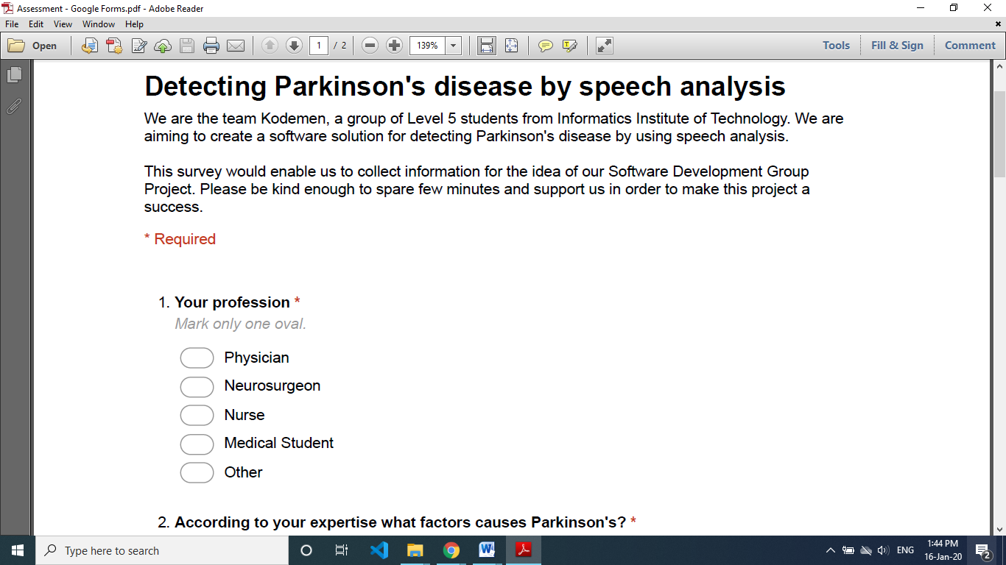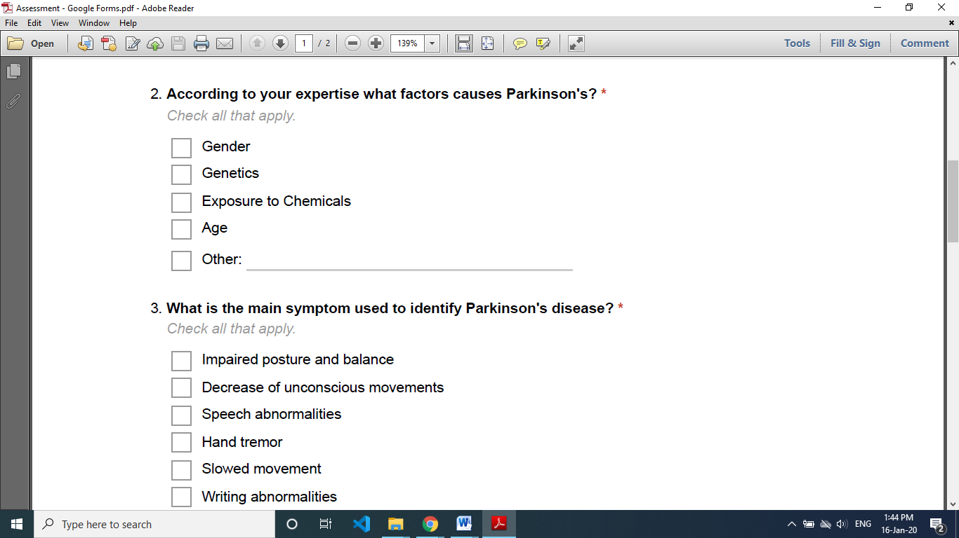

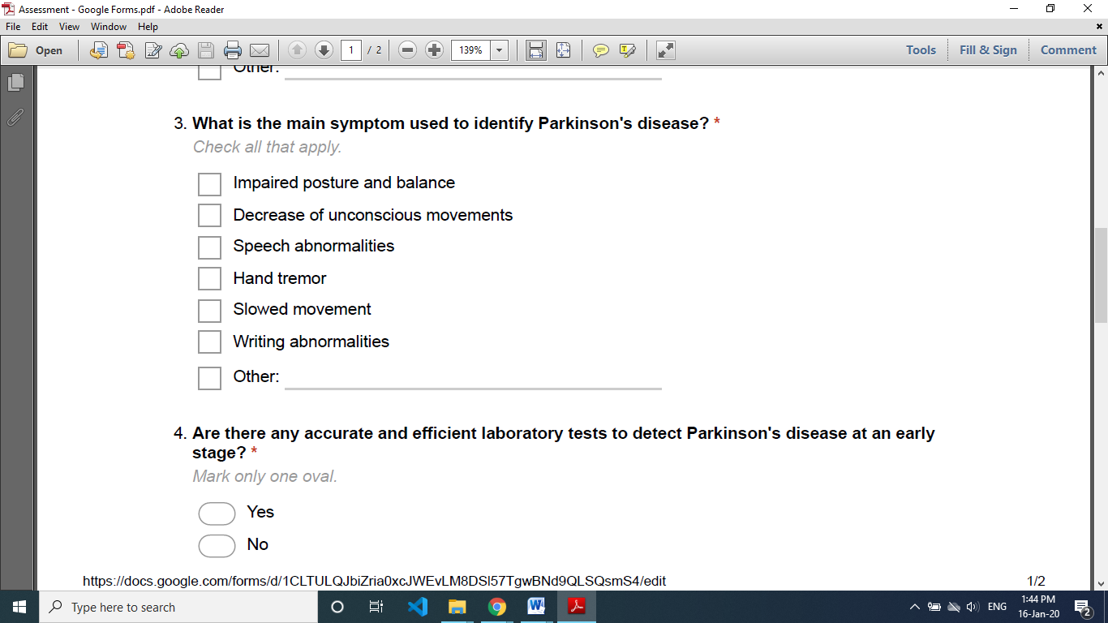



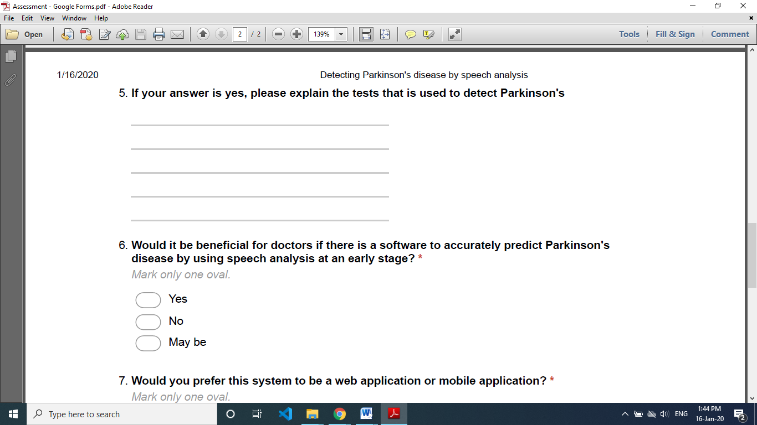

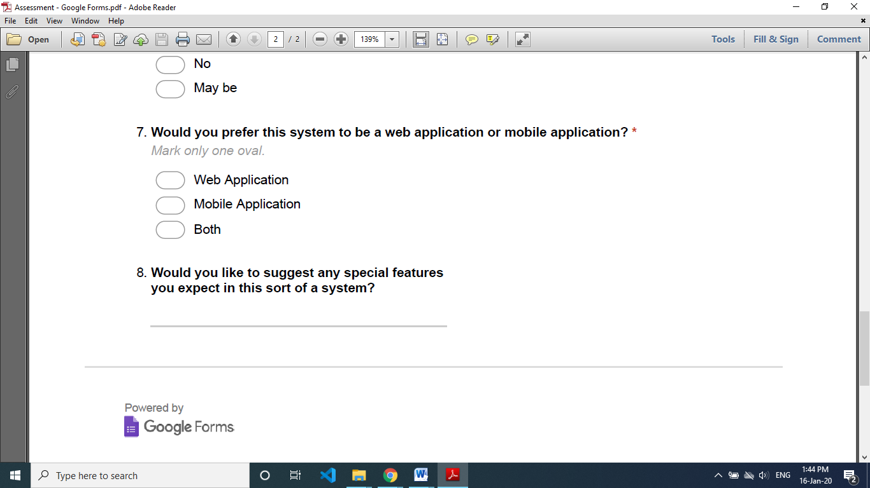

## Appendix B - Work breakdown structure

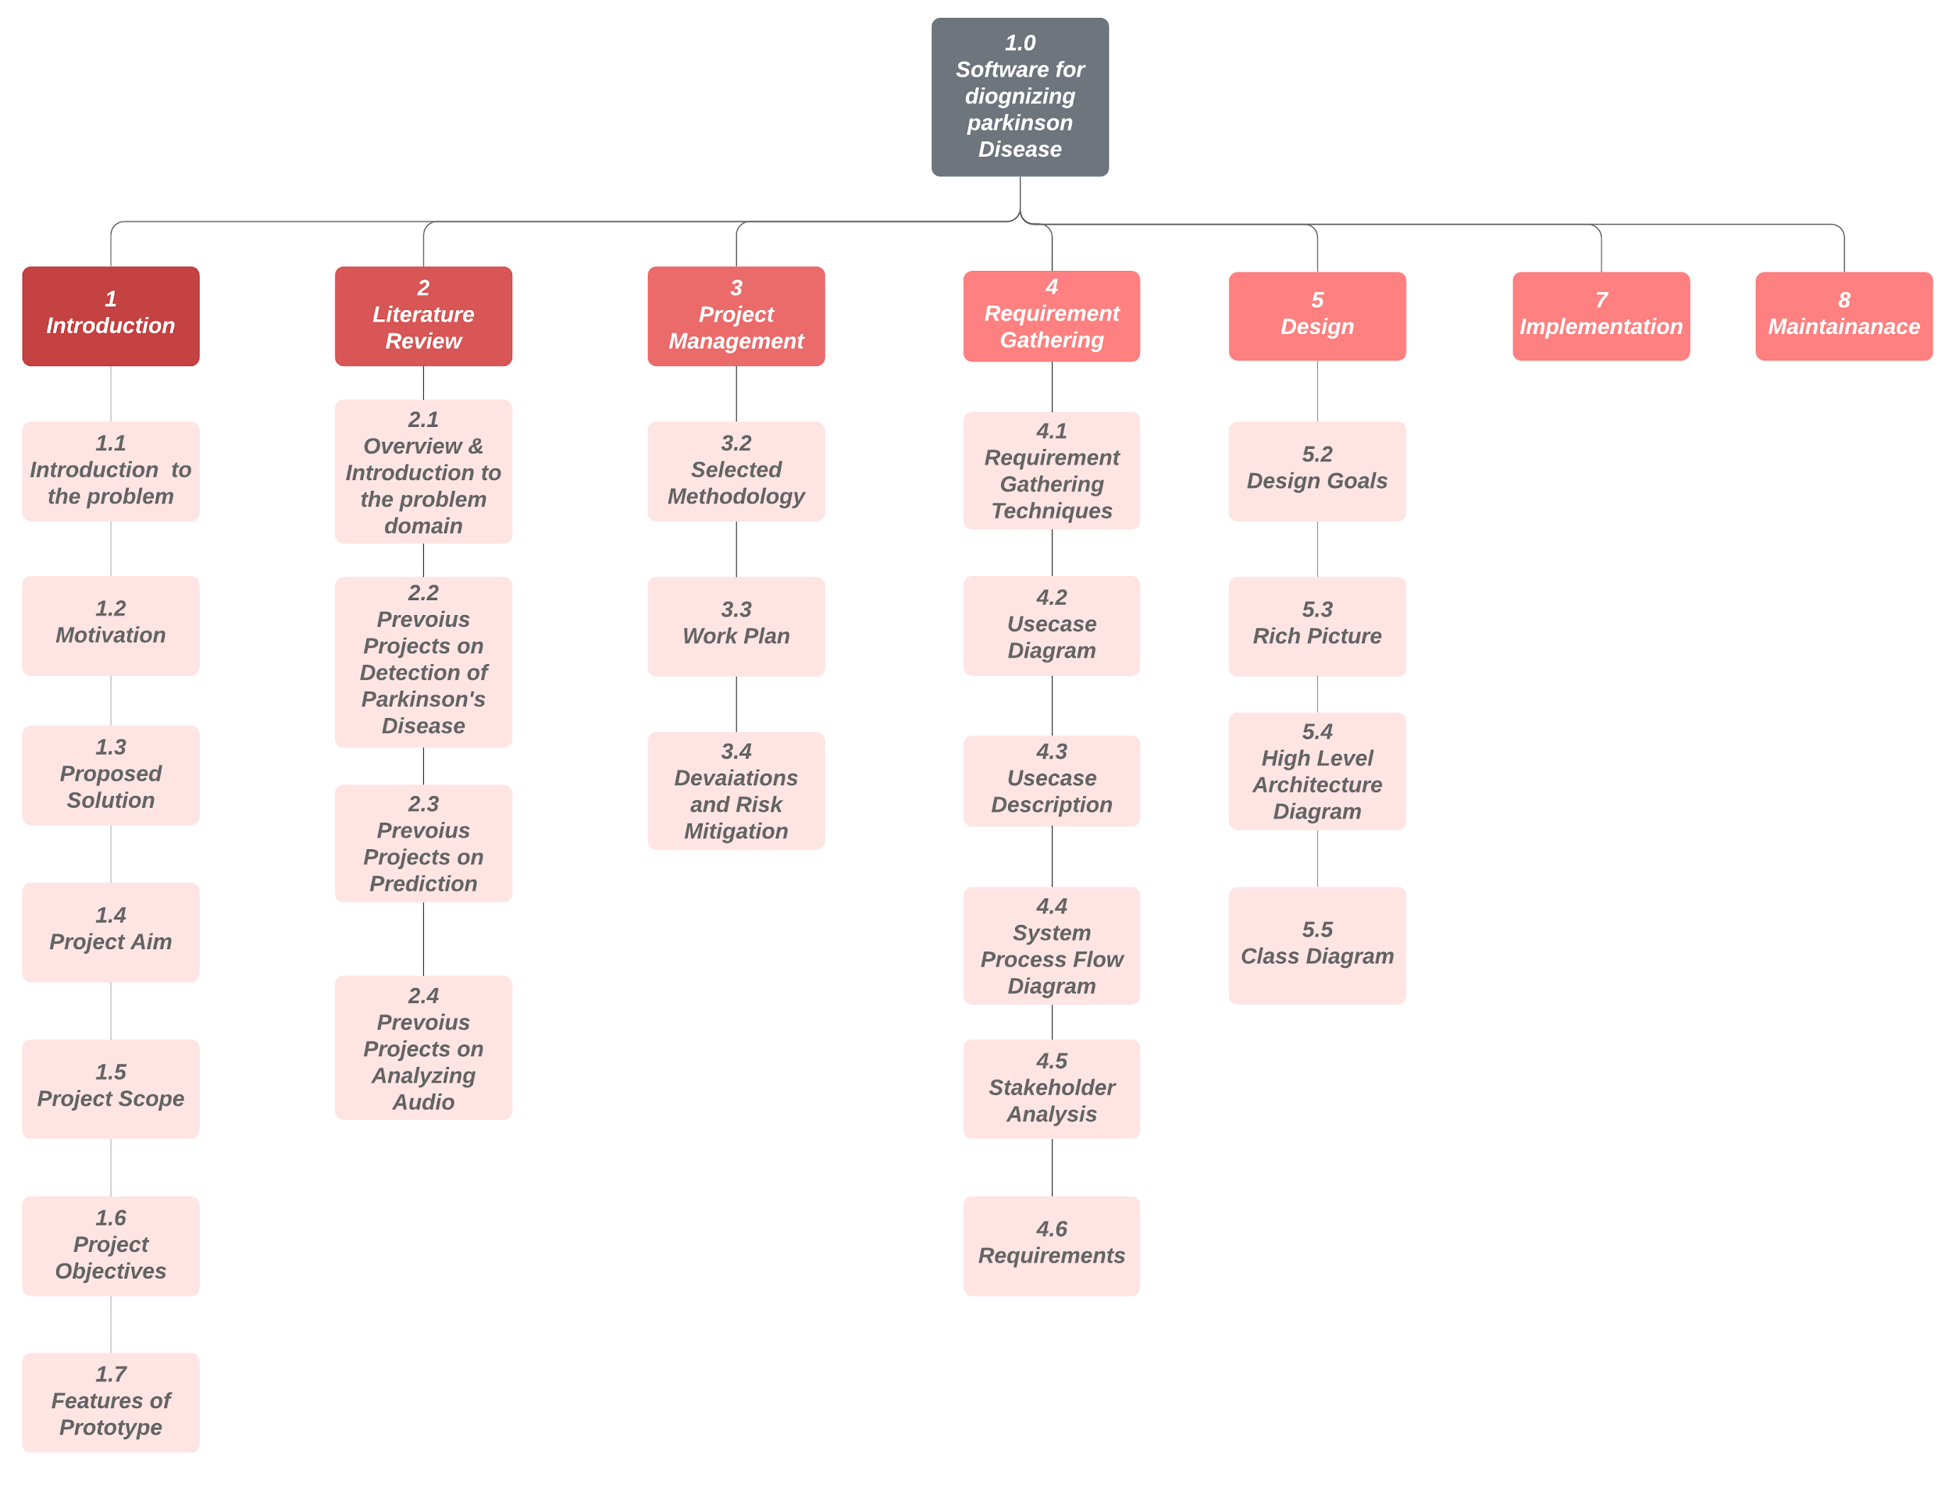

## Appendix C - Gantt chart

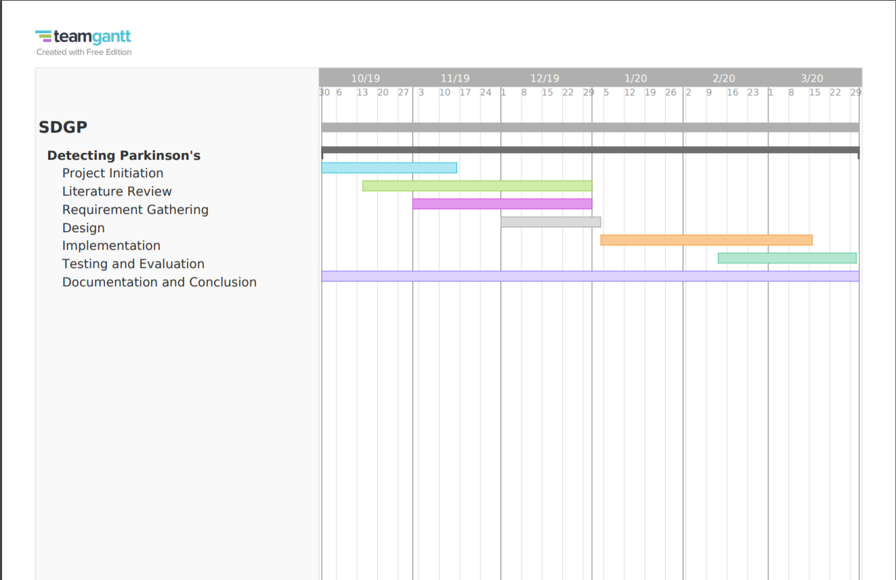

## Appendix D - Project Roles

|  |  |  |  |
| --- | --- | --- | --- |
| **Role** | | **Responsibility** | **Objectives** |
| SCRUM Master | | Naseef N | * Maintaining the AGILE principles among the group. * Identifying the strengths and weaknesses of the group and acting on it * Monitoring the Sprints and the objectives. |
| Vaseekaran V |
| Development Team | Data Science (Lead) | Rajeev K | * Lead the team in Data Science. * Learn data modelling. |
| Data Science | Vaseekaran V | * Learn data modelling * Assist the team in server-side development. |
| Client-Side Development (Lead) | Ashfaq K | * Lead the team in designing the UI/UX. * Assist the team in server-side development. |
| Client-Side Development | Sarvetha N | * Learn client-side development (Angular/React). * Assist the team in server-side management. |
| Server-Side Development (Lead) | Naseef N | * Lead the team in designing the back-end of the system. * Assist the team in data science. |
| Server-Side Development | Ashfak A | * Learn server-side development. * Assist the team in Client-side development (React/Angular) |
| Blockchain Features (Optional) | Ashfak A  (Lead) | * Lead the team in additional improvement to project using blockchain. * Research for possible ways to effectively utilize blockchain to the system |
| Vaseekaran V | * Research for possible ways to effectively utilize blockchain to the system |
| Documentation | Sarvetha N (Lead) | * Lead the team in the documentation of the project. * Properly document each sprint and sprint retrospective. |
| [Rest of the team] | * Properly document the necessary details after each sprint. |

## Appendix E - UI wire frame

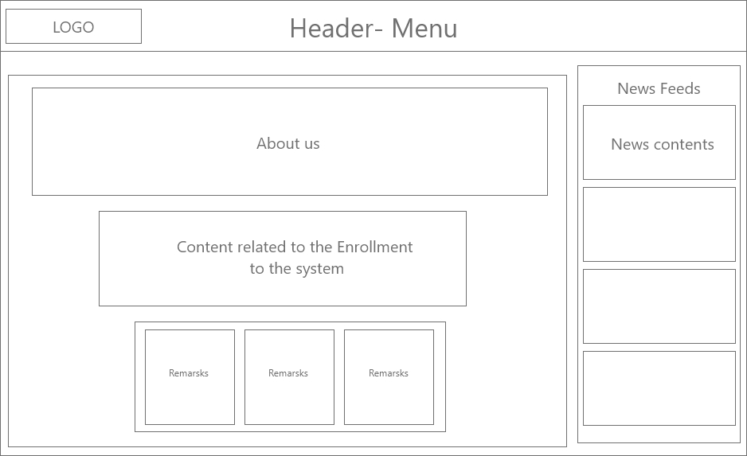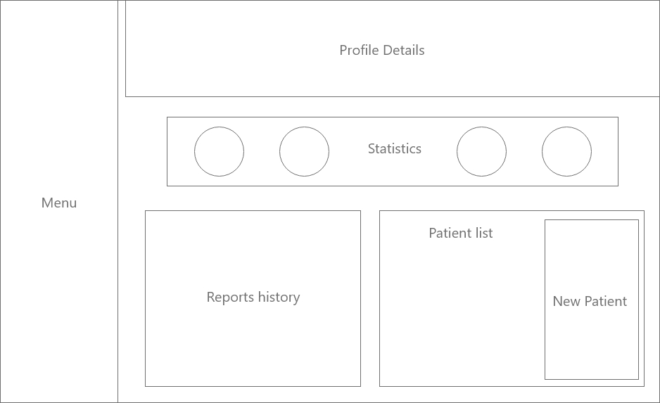

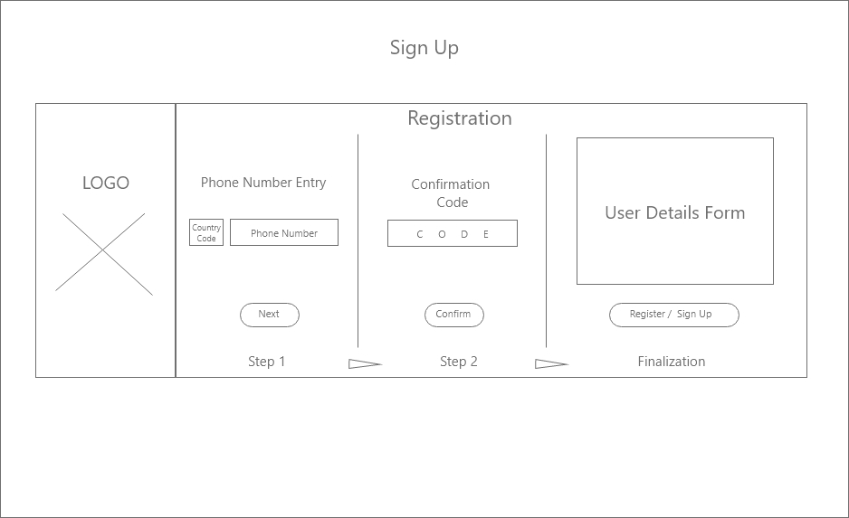

## Appendix F – Proposal and permission letter

A draft of our project proposal given to the National Hospital of Sri Lanka

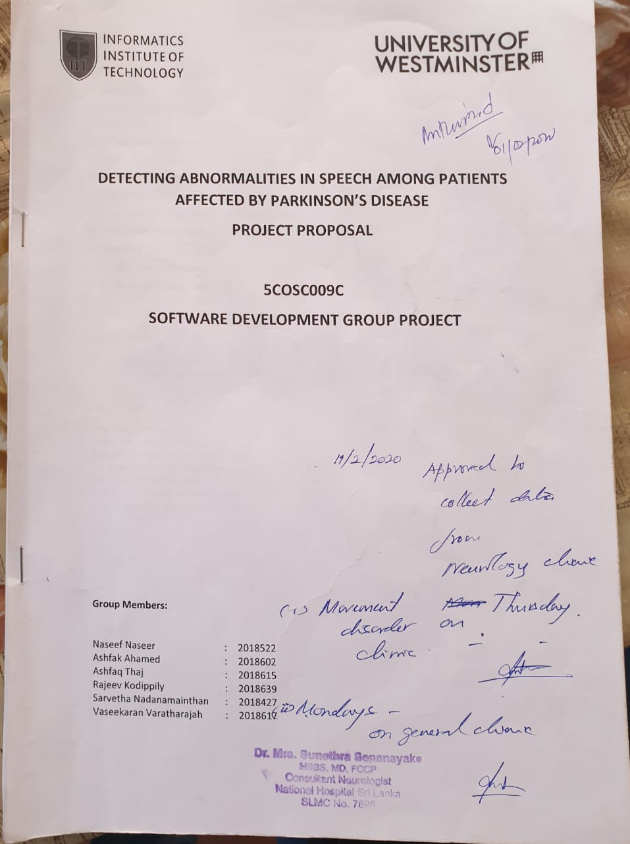

An official letter from the National Hospital of Sri Lanka.

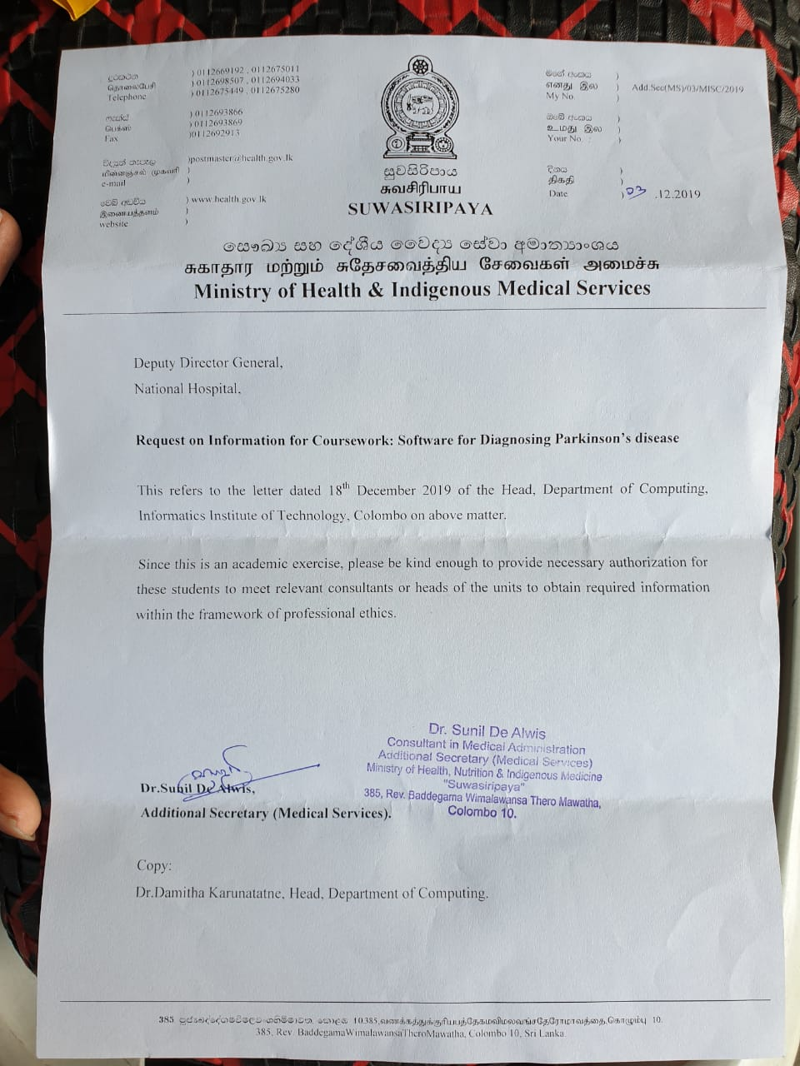

## Appendix G – Consent forms

English form

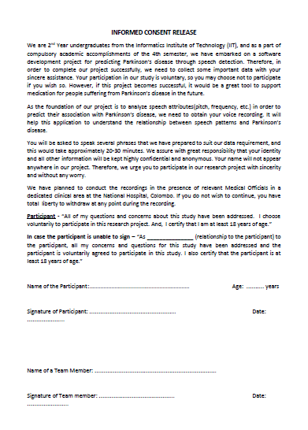

Tamil form

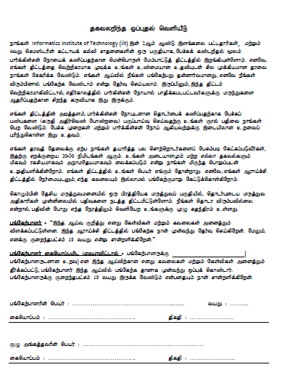

Sinhala form

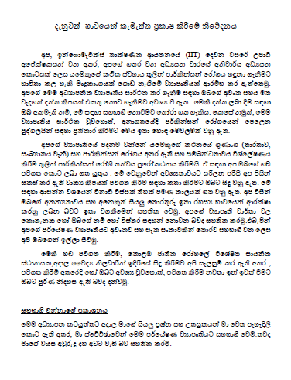

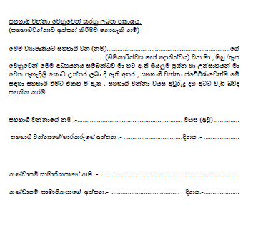

## Appendix G – Words

Tamil words and sentences

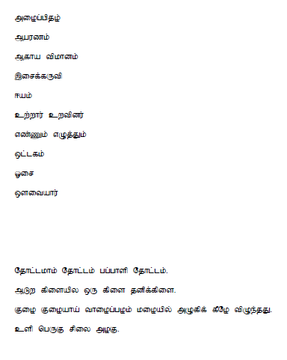

Sinhala words and sentences

## Appendix H – Pictures of recording patients voice

